# Lernkontrolle 6 / 4. Schuljahr / Aufgabenangebot

# Thema: Vertiefung, Ergänzung und Ausblick

# Kontrollaufgaben ZB 4: S. 88 - 106

# UNBEDINGT AUFGABENAUSWAHL TREFFEN

|  |  |  |  |
| --- | --- | --- | --- |
| **1.** | **Arithmetik: TILL-Zahlen** | **S. 88 / 89** | **O/B** |

|  |  |  |  |  |  |  |  |  |  |  |  |  |  |  |  |  |  |  |  |  |  |  |  |  |  |  |
| --- | --- | --- | --- | --- | --- | --- | --- | --- | --- | --- | --- | --- | --- | --- | --- | --- | --- | --- | --- | --- | --- | --- | --- | --- | --- | --- |
|  | 6 | 6 | 1 | 3 |  |  |  | 8 | 4 | 1 | 1 |  |  |  | 4 | 4 | 1 | 7 |  |  |  | 8 | 9 | 3 | 3 |  |
| **+** | 1 | 3 | 6 | 6 |  |  | **+** | 1 | 1 | 8 | 4 |  |  | **–** | 1 | 7 | 4 | 4 |  |  | **–** | 3 | 3 | 8 | 9 |  |
|  |  |  |  |  |  |  |  |  |  |  |  |  |  |  |  |  |  |  |  |  |  |  |  |  |  |  |
|  |  |  |  |  |  |  |  |  |  |  |  |  |  |  |  |  |  |  |  |  |  |  |  |  |  |  |
|  |  |  |  |  |  |  |  |  |  |  |  |  |  |  |  |  |  |  |  |  |  |  |  |  |  |  |
|  |  |  |  |  |  |  |  |  |  |  |  |  |  |  |  |  |  |  |  |  |  |  |  |  |  |  |
|  |  |  |  |  |  |  |  |  |  |  |  |  |  |  |  |  |  |  |  |  |  |  |  |  |  |  |
| ( | 6 | 6 | **+** | 1 | 3 | ) | **🞄** | 1 | 0 | 1 |  |  |  |  | ( | 6 | 6 | **–** | 1 | 3 | ) | **🞄** | 9 | 9 |  |  |
|  |  |  |  |  |  |  |  |  |  |  |  |  |  |  |  |  |  |  |  |  |  |  |  |  |  |  |
|  |  |  |  |  |  |  |  |  |  |  |  |  |  |  |  |  |  |  |  |  |  |  |  |  |  |  |
|  |  |  |  |  |  |  |  |  |  |  |  |  |  |  |  |  |  |  |  |  |  |  |  |  |  |  |
|  |  |  |  |  |  |  |  |  |  |  |  |  |  |  |  |  |  |  |  |  |  |  |  |  |  |  |
|  |  |  |  |  |  |  |  |  |  |  |  |  |  |  |  |  |  |  |  |  |  |  |  |  |  |  |
|  |  |  |  |  |  |  |  |  |  |  |  |  |  |  |  |  |  |  |  |  |  |  |  |  |  |  |
|  |  |  |  |  |  |  |  |  |  |  |  |  |  |  |  |  |  |  |  |  |  |  |  |  |  |  |
|  |  |  |  |  |  |  |  |  |  |  |  |  |  |  |  |  |  |  |  |  |  |  |  |  |  |  |

|  |  |  |  |
| --- | --- | --- | --- |
| **2.** | **Arithmetik: ANNA-Zahlen** | **S. 88 / 89** | **M/D** |

Bilde zu einer Anna- Zahl die andere Anna-Zahl und subtrahiere die kleinere von der grösseren, wie im Beispiel. Findest du verschiedene Beispiele, die die gleiche Differenz (das gleiche Resultat) ergeben?

Welches Ergebnis kann es sein?

|  |  |  |  |  |  |  |  |  |  |  |  |  |  |  |  |  |  |  |  |  |  |  |  |  |  |
| --- | --- | --- | --- | --- | --- | --- | --- | --- | --- | --- | --- | --- | --- | --- | --- | --- | --- | --- | --- | --- | --- | --- | --- | --- | --- |
|  | 6 | 3 | 3 | 6 |  |  |  |  |  |  |  |  |  |  |  |  |  |  |  |  |  |  |  |  |  |
| **–** | 3 | 6 | 6 | 3 |  |  |  |  |  |  |  |  |  |  |  |  |  |  |  |  |  |  |  |  |  |
|  |  |  |  |  |  |  |  |  |  |  |  |  |  |  |  |  |  |  |  |  |  |  |  |  |  |
|  | 2 | 6 | 7 | 3 |  |  |  |  |  |  |  |  |  |  |  |  |  |  |  |  |  |  |  |  |  |
|  |  |  |  |  |  |  |  |  |  |  |  |  |  |  |  |  |  |  |  |  |  |  |  |  |  |
|  |  |  |  |  |  |  |  |  |  |  |  |  |  |  |  |  |  |  |  |  |  |  |  |  |  |
|  |  |  |  |  |  |  |  |  |  |  |  |  |  |  |  |  |  |  |  |  |  |  |  |  |  |
|  |  |  |  |  |  |  |  |  |  |  |  |  |  |  |  |  |  |  |  |  |  |  |  |  |  |
|  |  |  |  |  |  |  |  |  |  |  |  |  |  |  |  |  |  |  |  |  |  |  |  |  |  |
|  |  |  |  |  |  |  |  |  |  |  |  |  |  |  |  |  |  |  |  |  |  |  |  |  |  |
|  |  |  |  |  |  |  |  |  |  |  |  |  |  |  |  |  |  |  |  |  |  |  |  |  |  |

|  |  |  |  |
| --- | --- | --- | --- |
| **3.** | **Arithmetik: Zahlenmauern** | **S. 90** | **O/B** |

|  |  |  |  |  |  |  |  |  |  |  |  |  |  |  |  |  |  |  |  |  |  |  |  |  |  |  |  |  |  |
| --- | --- | --- | --- | --- | --- | --- | --- | --- | --- | --- | --- | --- | --- | --- | --- | --- | --- | --- | --- | --- | --- | --- | --- | --- | --- | --- | --- | --- | --- |
| 285  560  1100  245  255  265 | | | | | | | | | | | | | | | | | | | | | | | | | | | | | |
|  |  |  |  |  |  |  |  |  |  |  |  |  |  |  |  |  |  |  |  |  |  |  |  |  |  |  |  |  |  | |
|  |  |  |  |  |  |  |  |  |  |  |  |  |  |  |  |  |  |  |  |  |  |  |  |  |  |  |  |  |  | |
|  |  |  |  |  |  |  |  |  |  |  |  |  |  |  |  |  |  |  |  |  |  |  |  |  |  |  |  |  |  | |
|  |  |  |  |  |  |  |  |  |  |  |  |  |  |  |  |  |  |  |  |  |  |  |  |  |  |  |  |  |  | |
|  |  |  |  |  |  |  |  |  |  |  |  |  |  |  |  |  |  |  |  |  |  |  |  |  |  |  |  |  |  | |
|  |  |  |  |  |  |  |  |  |  |  |  |  |  |  |  |  |  |  |  |  |  |  |  |  |  |  |  |  |  | |

|  |  |  |  |
| --- | --- | --- | --- |
| **4.** | **Arithmetik: Zahlenmauern** | **S. 90** | **O/B** |

Wie muss der mittlere Grundstein verändert werden, damit bei der Zahlenmauer B als Ergebnis 1070 entsteht?

**A B**

|  |
| --- |
| 1070  275  255  285  255  285 |

|  |  |  |  |
| --- | --- | --- | --- |
| **5.** | **Arithmetik: Zahlen an der Stellentafel** | **S. 91** | **M/D** |

|  |
| --- |
| Welche Zahlen kannst du mit 2 Plättchen legen? Schreibe möglichst viele Lösungen auf. |
| |  |  |  |  |  |  |  | | --- | --- | --- | --- | --- | --- | --- | | M | HT | ZT | T | H | Z | E | | ● |  | ● |  |  |  |  |   1'010’000 |

|  |  |  |  |  |  |  |  |  |  |  |  |  |  |  |  |  |  |  |  |  |  |  |  |  |  |  |  |  |  |  |  |  |
| --- | --- | --- | --- | --- | --- | --- | --- | --- | --- | --- | --- | --- | --- | --- | --- | --- | --- | --- | --- | --- | --- | --- | --- | --- | --- | --- | --- | --- | --- | --- | --- | --- |
|  |  |  |  |  |  |  |  |  |  |  |  |  |  |  |  |  |  |  |  |  |  |  |  |  |  |  |  |  |  |  |  |  |
|  |  |  |  |  |  |  |  |  |  |  |  |  |  |  |  |  |  |  |  |  |  |  |  |  |  |  |  |  |  |  |  |  |
|  |  |  |  |  |  |  |  |  |  |  |  |  |  |  |  |  |  |  |  |  |  |  |  |  |  |  |  |  |  |  |  |  |
|  |  |  |  |  |  |  |  |  |  |  |  |  |  |  |  |  |  |  |  |  |  |  |  |  |  |  |  |  |  |  |  |  |
|  |  |  |  |  |  |  |  |  |  |  |  |  |  |  |  |  |  |  |  |  |  |  |  |  |  |  |  |  |  |  |  |  |
|  |  |  |  |  |  |  |  |  |  |  |  |  |  |  |  |  |  |  |  |  |  |  |  |  |  |  |  |  |  |  |  |  |

|  |  |  |  |
| --- | --- | --- | --- |
| **6.** | **Arithmetik: Zahlen an der Stellentafel** | **S. 91** | **M/D & E/A** |

|  |
| --- |
| Lege einige Zahlen mit 2 oder 3 Plättchen? Dividiere diese Zahlen durch 9.  Was fällt dir auf? |
| |  |  |  |  |  | | --- | --- | --- | --- | --- | | ZT | T | H | Z | E | |  |  |  |  |  | |

|  |  |  |  |  |  |  |  |  |  |  |  |  |  |  |  |  |  |  |  |  |  |  |  |  |  |  |  |  |  |  |  |  |
| --- | --- | --- | --- | --- | --- | --- | --- | --- | --- | --- | --- | --- | --- | --- | --- | --- | --- | --- | --- | --- | --- | --- | --- | --- | --- | --- | --- | --- | --- | --- | --- | --- |
|  |  |  |  |  |  |  |  |  |  |  |  |  |  |  |  |  |  |  |  |  |  |  |  |  |  |  |  |  |  |  |  |  |
|  |  |  |  |  |  |  |  |  |  |  |  |  |  |  |  |  |  |  |  |  |  |  |  |  |  |  |  |  |  |  |  |  |
|  |  |  |  |  |  |  |  |  |  |  |  |  |  |  |  |  |  |  |  |  |  |  |  |  |  |  |  |  |  |  |  |  |
|  |  |  |  |  |  |  |  |  |  |  |  |  |  |  |  |  |  |  |  |  |  |  |  |  |  |  |  |  |  |  |  |  |
|  |  |  |  |  |  |  |  |  |  |  |  |  |  |  |  |  |  |  |  |  |  |  |  |  |  |  |  |  |  |  |  |  |
|  |  |  |  |  |  |  |  |  |  |  |  |  |  |  |  |  |  |  |  |  |  |  |  |  |  |  |  |  |  |  |  |  |
|  |  |  |  |  |  |  |  |  |  |  |  |  |  |  |  |  |  |  |  |  |  |  |  |  |  |  |  |  |  |  |  |  |
|  |  |  |  |  |  |  |  |  |  |  |  |  |  |  |  |  |  |  |  |  |  |  |  |  |  |  |  |  |  |  |  |  |

|  |  |  |  |
| --- | --- | --- | --- |
| **7.** | **Arithmetik: Division** | **S. 91** | **O/B** |

Das Ergebnis einer Aufgabe passt nicht ins Päckchen.

Rechne halbschriftlich und verändere diese Rechnung, so dass ihr Ergebnis zu den zwei anderen passt.

|  |  |  |  |  |  |  |  |  |  |  |  |  |  |  |  |  |  |  |  |  |  |  |  |  |  |  |  |  |  |  |  |
| --- | --- | --- | --- | --- | --- | --- | --- | --- | --- | --- | --- | --- | --- | --- | --- | --- | --- | --- | --- | --- | --- | --- | --- | --- | --- | --- | --- | --- | --- | --- | --- |
| 7 | 4 | 0 | 4 | : | 6 | = |  |  |  |  |  |  |  |  |  |  |  |  |  |  |  |  |  |  |  |  |  |  |  |  |  |
|  |  |  |  |  |  |  |  |  |  |  |  |  |  |  |  |  |  |  |  |  |  |  |  |  |  |  |  |  |  |  |  |
|  |  |  |  |  |  |  |  |  |  |  |  |  |  |  |  |  |  |  |  |  |  |  |  |  |  |  |  |  |  |  |  |
|  |  |  |  |  |  |  |  |  |  |  |  |  |  |  |  |  |  |  |  |  |  |  |  |  |  |  |  |  |  |  |  |
| 4 | 9 | 4 | 0 | : | 4 | = |  |  |  |  |  |  |  |  |  |  |  |  |  |  |  |  |  |  |  |  |  |  |  |  |  |
|  |  |  |  |  |  |  |  |  |  |  |  |  |  |  |  |  |  |  |  |  |  |  |  |  |  |  |  |  |  |  |  |
|  |  |  |  |  |  |  |  |  |  |  |  |  |  |  |  |  |  |  |  |  |  |  |  |  |  |  |  |  |  |  |  |
|  |  |  |  |  |  |  |  |  |  |  |  |  |  |  |  |  |  |  |  |  |  |  |  |  |  |  |  |  |  |  |  |
| 1 | 1 | 1 | 0 | 6 | : | 9 | = |  |  |  |  |  |  |  |  |  |  |  |  |  |  |  |  |  |  |  |  |  |  |  |  |
|  |  |  |  |  |  |  |  |  |  |  |  |  |  |  |  |  |  |  |  |  |  |  |  |  |  |  |  |  |  |  |  |
|  |  |  |  |  |  |  |  |  |  |  |  |  |  |  |  |  |  |  |  |  |  |  |  |  |  |  |  |  |  |  |  |
|  |  |  |  |  |  |  |  |  |  |  |  |  |  |  |  |  |  |  |  |  |  |  |  |  |  |  |  |  |  |  |  |

|  |  |  |  |
| --- | --- | --- | --- |
| **8.** | **Arithmetik: Zahlenrätsel** | **S. 92** | **M/D** |

|  |  |  |  |  |  |  |  |  |  |  |  |  |  |  |  |  |  |  |  |  |  |  |  |  |  |  |  |  |  |
| --- | --- | --- | --- | --- | --- | --- | --- | --- | --- | --- | --- | --- | --- | --- | --- | --- | --- | --- | --- | --- | --- | --- | --- | --- | --- | --- | --- | --- | --- |
| Ich denke mir eine Zahl, addiere 5, dividiere durch 3, multipliziere mit 5 und erhalte 25.  Welche Zahl habe ich mir gedacht? Schreibe deine Überlegungen auf oder mache eine Skizze,  wie du die Aufgabe gelöst hast. | | | | | | | | | | | | | | | | | | | | | | | | | | | | | |
|  |  |  |  |  |  |  |  |  |  |  |  |  |  |  |  |  |  |  |  |  |  |  |  |  |  |  |  |  |  |
|  |  |  |  |  |  |  |  |  |  |  |  |  |  |  |  |  |  |  |  |  |  |  |  |  |  |  |  |  |  |
|  |  |  |  |  |  |  |  |  |  |  |  |  |  |  |  |  |  |  |  |  |  |  |  |  |  |  |  |  |  |
|  |  |  |  |  |  |  |  |  |  |  |  |  |  |  |  |  |  |  |  |  |  |  |  |  |  |  |  |  |  |

|  |  |  |  |
| --- | --- | --- | --- |
| **9.** | **Arithmetik: Zahlenrätsel** | **S. 92** | **M/D** |

|  |  |  |  |  |  |  |  |  |  |  |  |  |  |  |  |  |  |  |  |  |  |  |  |  |  |  |  |  |  |
| --- | --- | --- | --- | --- | --- | --- | --- | --- | --- | --- | --- | --- | --- | --- | --- | --- | --- | --- | --- | --- | --- | --- | --- | --- | --- | --- | --- | --- | --- |
| Ich denke mir eine zweistellige Zahl, vertausche die beiden Ziffern, dividiere durch 3 und erhalte 15  Welche Zahl habe ich mir gedacht? Schreibe deine Überlegungen auf oder mache eine Skizze,  wie du die Aufgabe gelöst hast. | | | | | | | | | | | | | | | | | | | | | | | | | | | | | |
|  |  |  |  |  |  |  |  |  |  |  |  |  |  |  |  |  |  |  |  |  |  |  |  |  |  |  |  |  |  |
|  |  |  |  |  |  |  |  |  |  |  |  |  |  |  |  |  |  |  |  |  |  |  |  |  |  |  |  |  |  |
|  |  |  |  |  |  |  |  |  |  |  |  |  |  |  |  |  |  |  |  |  |  |  |  |  |  |  |  |  |  |
|  |  |  |  |  |  |  |  |  |  |  |  |  |  |  |  |  |  |  |  |  |  |  |  |  |  |  |  |  |  |

|  |  |  |  |
| --- | --- | --- | --- |
| **10.** | **Arithmetik: Ungleichungen** | **S.93** | **O/B** |

Dir stehen die Ziffern von 0- 9 zur Verfügung.

Welche Zahl kann x sein?

x • 400 > 1700

|  |  |  |  |
| --- | --- | --- | --- |
| **11.** | **Sachrechnen: Berg- und Seilbahnen** | **S. 96** | **M/D** |

|  |  |  |  |  |  |  |  |  |  |  |
| --- | --- | --- | --- | --- | --- | --- | --- | --- | --- | --- |
| |  |  | | --- | --- | | Strecke | Beatenberg – Niederhorn | | Personen pro Gondel | 16 Personen | | Talstation Beatenberg | 1127 m über Meer | | Bergstation Niederhorn | 1935 m über Meer | | Fahrzeit Tal – Berg | 9 Minuten |   2131279167_07a1133b85 |

1. Berechne die Höhendifferenz
2. Es fahren gleichzeitig drei Gondeln bergwärts und drei Gondeln talwärts. Berechne und erkläre, wie viele Leute die Bahn pro Stunde auf das Niederhorn transportieren kann.

|  |  |  |  |  |  |  |  |  |  |  |  |  |  |  |  |  |  |  |  |  |  |  |  |  |  |  |  |
| --- | --- | --- | --- | --- | --- | --- | --- | --- | --- | --- | --- | --- | --- | --- | --- | --- | --- | --- | --- | --- | --- | --- | --- | --- | --- | --- | --- |
|  |  |  |  |  |  |  |  |  |  |  |  |  |  |  |  |  |  |  |  |  |  |  |  |  |  |  |  |
|  |  |  |  |  |  |  |  |  |  |  |  |  |  |  |  |  |  |  |  |  |  |  |  |  |  |  |  |
|  |  |  |  |  |  |  |  |  |  |  |  |  |  |  |  |  |  |  |  |  |  |  |  |  |  |  |  |
|  |  |  |  |  |  |  |  |  |  |  |  |  |  |  |  |  |  |  |  |  |  |  |  |  |  |  |  |
|  |  |  |  |  |  |  |  |  |  |  |  |  |  |  |  |  |  |  |  |  |  |  |  |  |  |  |  |
|  |  |  |  |  |  |  |  |  |  |  |  |  |  |  |  |  |  |  |  |  |  |  |  |  |  |  |  |

|  |  |  |  |
| --- | --- | --- | --- |
| **12.** | **Sachrechnen: Berg- und Seilbahnen** | **S. 96** | **M/D** |

|  |  |  |  |  |  |  |  |  |  |  |  |  |  |  |  |  |  |  |
| --- | --- | --- | --- | --- | --- | --- | --- | --- | --- | --- | --- | --- | --- | --- | --- | --- | --- | --- |
| |  |  | | --- | --- | | Strecke | Beatenberg – Niederhorn | | Anzahl Gondeln | 4 mal 3 Gondeln | | Personen pro Gondel | 16 Personen | | Kapazität | 600 Personen pro Stunde | | Länge der Bahn | 2493 m | | Talstation Beatenberg | 1127 m über Meer | | Bergstation Niederhorn | 1935 m über Meer | | Tragseile | 4 mal 2780 m lang,  total 124 Tonnen schwer | | Fahrzeit Tal – Berg | 9 Minuten |   2131279167_07a1133b85 |
| Erfinde mit den gegebenen Informationen zwei Sachaufgaben.  Formuliere deine Fragen. Schreibe die Überlegungen und Antworten dazu auf. |

|  |  |  |  |  |  |  |  |  |  |  |  |  |  |  |  |  |  |  |  |  |  |  |  |  |  |  |  |
| --- | --- | --- | --- | --- | --- | --- | --- | --- | --- | --- | --- | --- | --- | --- | --- | --- | --- | --- | --- | --- | --- | --- | --- | --- | --- | --- | --- |
|  |  |  |  |  |  |  |  |  |  |  |  |  |  |  |  |  |  |  |  |  |  |  |  |  |  |  |  |
|  |  |  |  |  |  |  |  |  |  |  |  |  |  |  |  |  |  |  |  |  |  |  |  |  |  |  |  |
|  |  |  |  |  |  |  |  |  |  |  |  |  |  |  |  |  |  |  |  |  |  |  |  |  |  |  |  |
|  |  |  |  |  |  |  |  |  |  |  |  |  |  |  |  |  |  |  |  |  |  |  |  |  |  |  |  |
|  |  |  |  |  |  |  |  |  |  |  |  |  |  |  |  |  |  |  |  |  |  |  |  |  |  |  |  |
|  |  |  |  |  |  |  |  |  |  |  |  |  |  |  |  |  |  |  |  |  |  |  |  |  |  |  |  |
|  |  |  |  |  |  |  |  |  |  |  |  |  |  |  |  |  |  |  |  |  |  |  |  |  |  |  |  |

|  |  |  |  |
| --- | --- | --- | --- |
| **13.** | **Sachrechnen: Brotverbrauch schätzen** | **S:98 / 99** | **M/D** |

|  |  |  |  |  |  |  |
| --- | --- | --- | --- | --- | --- | --- |
| Bild_BrotDer Brotverbrauch in der Schweiz beträgt pro Person und Tag etwa 130 Gramm.  Wie viel Brot isst eine Person ungefähr pro Monat?  Schätze und überschlage: Kreuze das richtige Ergebnis an. | | | | | | |
| 2 kg |  | 4 kg |  | 6 kg |  |

|  |  |  |  |  |  |  |  |  |  |  |  |  |  |  |  |  |  |  |  |  |  |  |  |  |  |  |  |
| --- | --- | --- | --- | --- | --- | --- | --- | --- | --- | --- | --- | --- | --- | --- | --- | --- | --- | --- | --- | --- | --- | --- | --- | --- | --- | --- | --- |
|  |  |  |  |  |  |  |  |  |  |  |  |  |  |  |  |  |  |  |  |  |  |  |  |  |  |  |  |
|  |  |  |  |  |  |  |  |  |  |  |  |  |  |  |  |  |  |  |  |  |  |  |  |  |  |  |  |
|  |  |  |  |  |  |  |  |  |  |  |  |  |  |  |  |  |  |  |  |  |  |  |  |  |  |  |  |
|  |  |  |  |  |  |  |  |  |  |  |  |  |  |  |  |  |  |  |  |  |  |  |  |  |  |  |  |
|  |  |  |  |  |  |  |  |  |  |  |  |  |  |  |  |  |  |  |  |  |  |  |  |  |  |  |  |
|  |  |  |  |  |  |  |  |  |  |  |  |  |  |  |  |  |  |  |  |  |  |  |  |  |  |  |  |
|  |  |  |  |  |  |  |  |  |  |  |  |  |  |  |  |  |  |  |  |  |  |  |  |  |  |  |  |
|  |  |  |  |  |  |  |  |  |  |  |  |  |  |  |  |  |  |  |  |  |  |  |  |  |  |  |  |

|  |  |  |  |
| --- | --- | --- | --- |
| **14.** | **Sachrechnen: Brotverbrauch schätzen** | **S:98 / 99** | **M/D** |

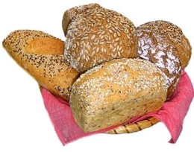

Der Brotverbrauch in der Schweiz beträgt pro Person und Tag etwa 130 Gramm.

Wie viel Brot isst eine Person ungefähr pro Monat?

|  |  |  |  |  |  |  |  |  |  |  |  |  |  |  |  |  |  |  |  |  |  |  |  |  |  |  |  |
| --- | --- | --- | --- | --- | --- | --- | --- | --- | --- | --- | --- | --- | --- | --- | --- | --- | --- | --- | --- | --- | --- | --- | --- | --- | --- | --- | --- |
|  |  |  |  |  |  |  |  |  |  |  |  |  |  |  |  |  |  |  |  |  |  |  |  |  |  |  |  |
|  |  |  |  |  |  |  |  |  |  |  |  |  |  |  |  |  |  |  |  |  |  |  |  |  |  |  |  |
|  |  |  |  |  |  |  |  |  |  |  |  |  |  |  |  |  |  |  |  |  |  |  |  |  |  |  |  |
|  |  |  |  |  |  |  |  |  |  |  |  |  |  |  |  |  |  |  |  |  |  |  |  |  |  |  |  |
|  |  |  |  |  |  |  |  |  |  |  |  |  |  |  |  |  |  |  |  |  |  |  |  |  |  |  |  |
|  |  |  |  |  |  |  |  |  |  |  |  |  |  |  |  |  |  |  |  |  |  |  |  |  |  |  |  |
|  |  |  |  |  |  |  |  |  |  |  |  |  |  |  |  |  |  |  |  |  |  |  |  |  |  |  |  |

|  |  |  |  |
| --- | --- | --- | --- |
| **15.** | **Sachrechnen: Wasserverbrauch bestimmen** | **S. 103** | **M/D** |

|  |  |  |  |  |  |  |  |  |  |  |  |  |  |  |  |  |  |  |  |  |  |  |  |  |  |  |  |  |  |  |
| --- | --- | --- | --- | --- | --- | --- | --- | --- | --- | --- | --- | --- | --- | --- | --- | --- | --- | --- | --- | --- | --- | --- | --- | --- | --- | --- | --- | --- | --- | --- |
| wassertropfen2Ein tropfender Wasserhahn verschwendet am Tag ungefähr 20 Liter Wasser.  Wie viele Liter sind das im Jahr?  Schreibe deine Rechnung auf. | | | | | | | | | | | | | | | | | | | | | | | | | | | | | | |
|  |  |  |  |  |  |  |  |  |  |  |  |  |  |  |  |  |  |  |  |  |  |  |  |  |  |  |  |  |  |
|  |  |  |  |  |  |  |  |  |  |  |  |  |  |  |  |  |  |  |  |  |  |  |  |  |  |  |  |  |  |
|  |  |  |  |  |  |  |  |  |  |  |  |  |  |  |  |  |  |  |  |  |  |  |  |  |  |  |  |  |  |

|  |  |  |  |  |  |
| --- | --- | --- | --- | --- | --- |
| Welches Ergebnis passt?  Kreuze es an. | 140 Liter |  | 600 Liter |  | 7300 Liter |

|  |  |  |  |
| --- | --- | --- | --- |
| **16.** | **Sachrechnen: Wasserverbrauch bestimmen** | **S. 103** | **M/D** |

Ein tropfender Wasserhahn verschwendet pro Stunde ungefähr 8dl Wasser.

Wie viele Liter sind das an einem Tag und in einem Jahr?

Schreibe deine Rechnung auf.

|  |  |  |  |  |  |  |  |  |  |  |  |  |  |  |  |  |  |  |  |  |  |  |  |  |  |  |  |
| --- | --- | --- | --- | --- | --- | --- | --- | --- | --- | --- | --- | --- | --- | --- | --- | --- | --- | --- | --- | --- | --- | --- | --- | --- | --- | --- | --- |
|  |  |  |  |  |  |  |  |  |  |  |  |  |  |  |  |  |  |  |  |  |  |  |  |  |  |  |  |
|  |  |  |  |  |  |  |  |  |  |  |  |  |  |  |  |  |  |  |  |  |  |  |  |  |  |  |  |
|  |  |  |  |  |  |  |  |  |  |  |  |  |  |  |  |  |  |  |  |  |  |  |  |  |  |  |  |
|  |  |  |  |  |  |  |  |  |  |  |  |  |  |  |  |  |  |  |  |  |  |  |  |  |  |  |  |
|  |  |  |  |  |  |  |  |  |  |  |  |  |  |  |  |  |  |  |  |  |  |  |  |  |  |  |  |
|  |  |  |  |  |  |  |  |  |  |  |  |  |  |  |  |  |  |  |  |  |  |  |  |  |  |  |  |
|  |  |  |  |  |  |  |  |  |  |  |  |  |  |  |  |  |  |  |  |  |  |  |  |  |  |  |  |

|  |  |  |  |
| --- | --- | --- | --- |
| **17.** | **Sachrechnen: Wasserverbrauch bestimmen** | **S. 103** | **M/D** |

Ein tropfender Wasserhahn verschwendet an einem Tag ungefähr 20 Liter Wasser.

1000 Liter Wasser kosten ungefähr 1.80 Fr.

Wie viele Liter sind das in einem Jahr und was kostet es?

Schreibe deine Rechnung auf.

|  |  |  |  |  |  |  |  |  |  |  |  |  |  |  |  |  |  |  |  |  |  |  |  |  |  |  |  |
| --- | --- | --- | --- | --- | --- | --- | --- | --- | --- | --- | --- | --- | --- | --- | --- | --- | --- | --- | --- | --- | --- | --- | --- | --- | --- | --- | --- |
|  |  |  |  |  |  |  |  |  |  |  |  |  |  |  |  |  |  |  |  |  |  |  |  |  |  |  |  |
|  |  |  |  |  |  |  |  |  |  |  |  |  |  |  |  |  |  |  |  |  |  |  |  |  |  |  |  |
|  |  |  |  |  |  |  |  |  |  |  |  |  |  |  |  |  |  |  |  |  |  |  |  |  |  |  |  |
|  |  |  |  |  |  |  |  |  |  |  |  |  |  |  |  |  |  |  |  |  |  |  |  |  |  |  |  |
|  |  |  |  |  |  |  |  |  |  |  |  |  |  |  |  |  |  |  |  |  |  |  |  |  |  |  |  |
|  |  |  |  |  |  |  |  |  |  |  |  |  |  |  |  |  |  |  |  |  |  |  |  |  |  |  |  |
|  |  |  |  |  |  |  |  |  |  |  |  |  |  |  |  |  |  |  |  |  |  |  |  |  |  |  |  |

|  |  |  |  |
| --- | --- | --- | --- |
| **18.** | **Arithmetik: Brüche** | **S. 104** | **O/B** |

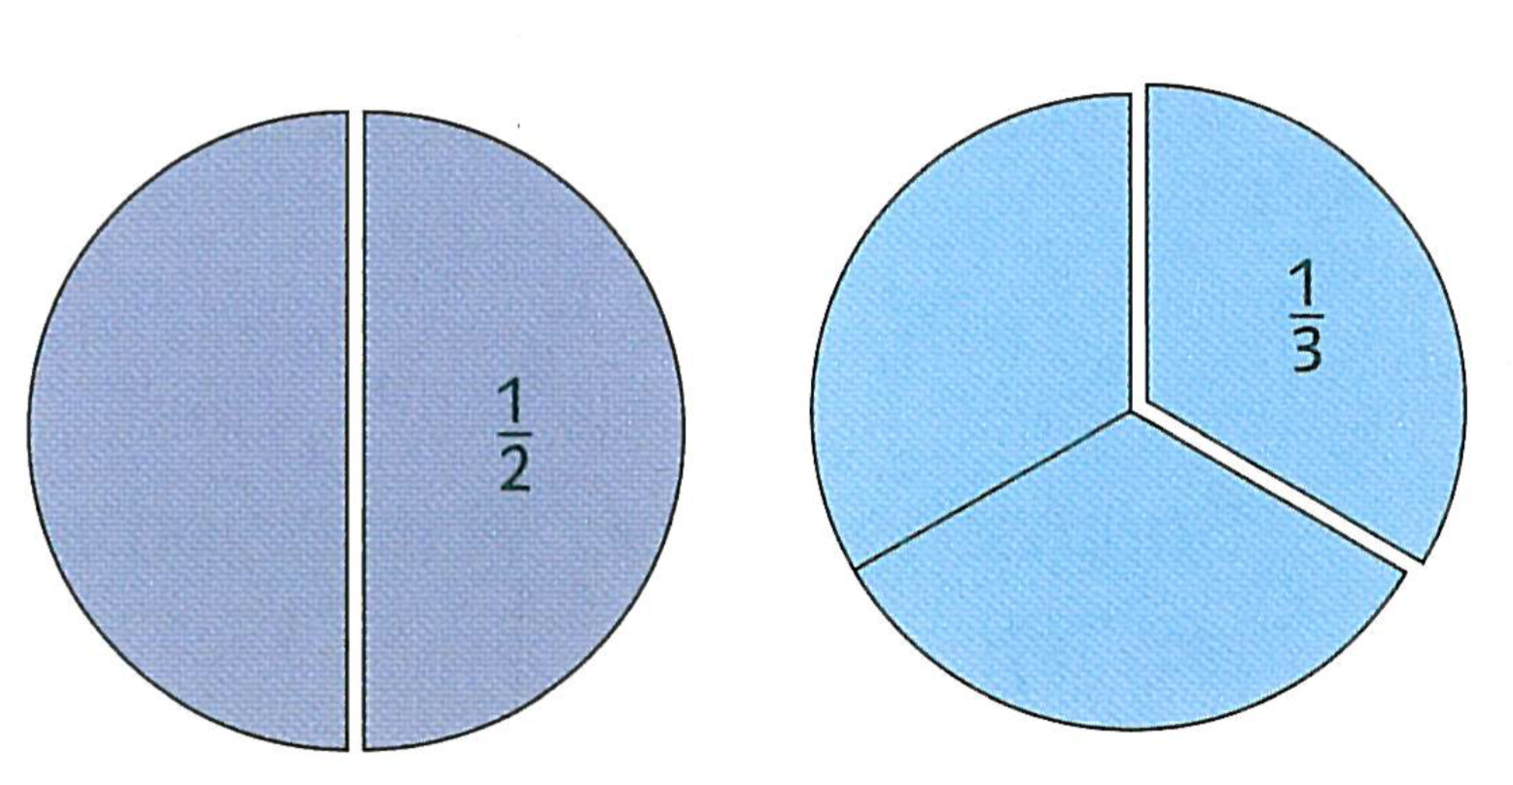 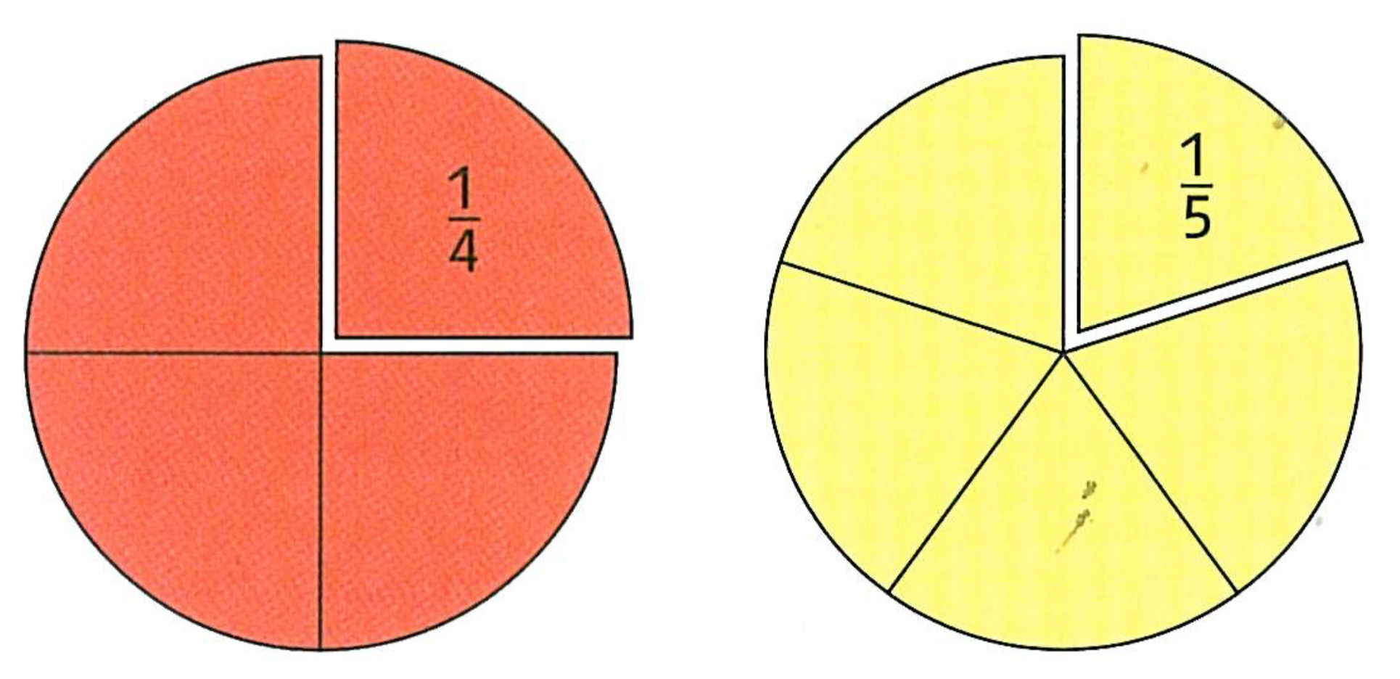

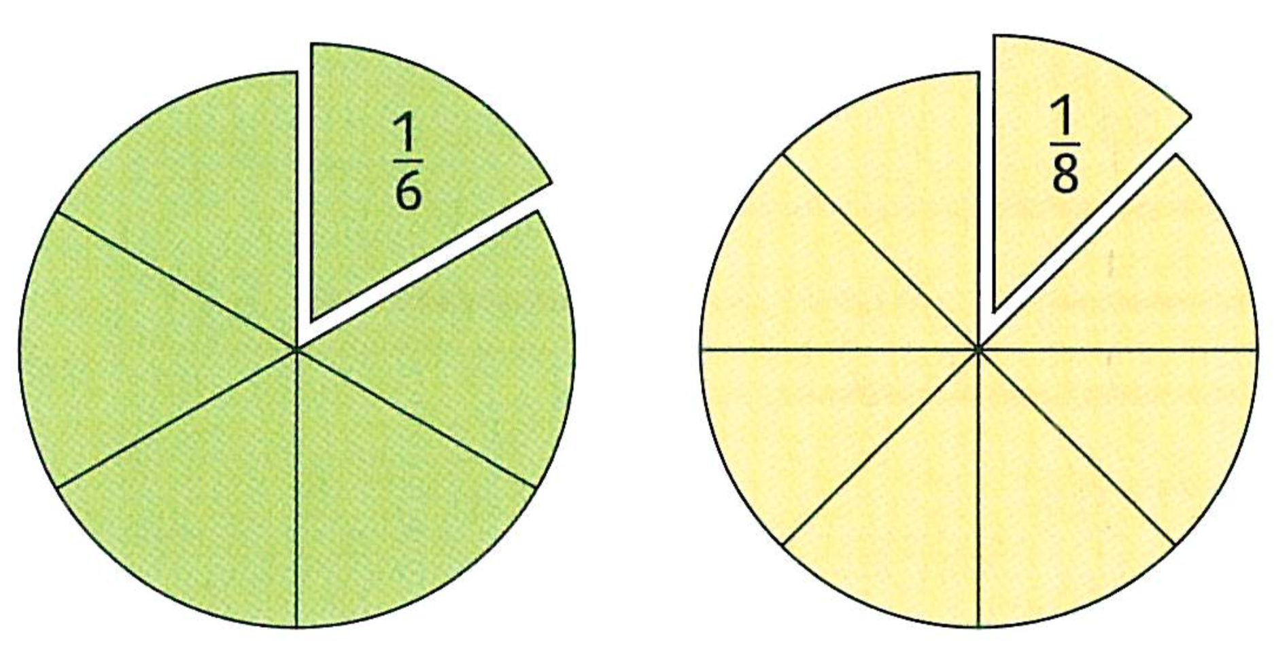 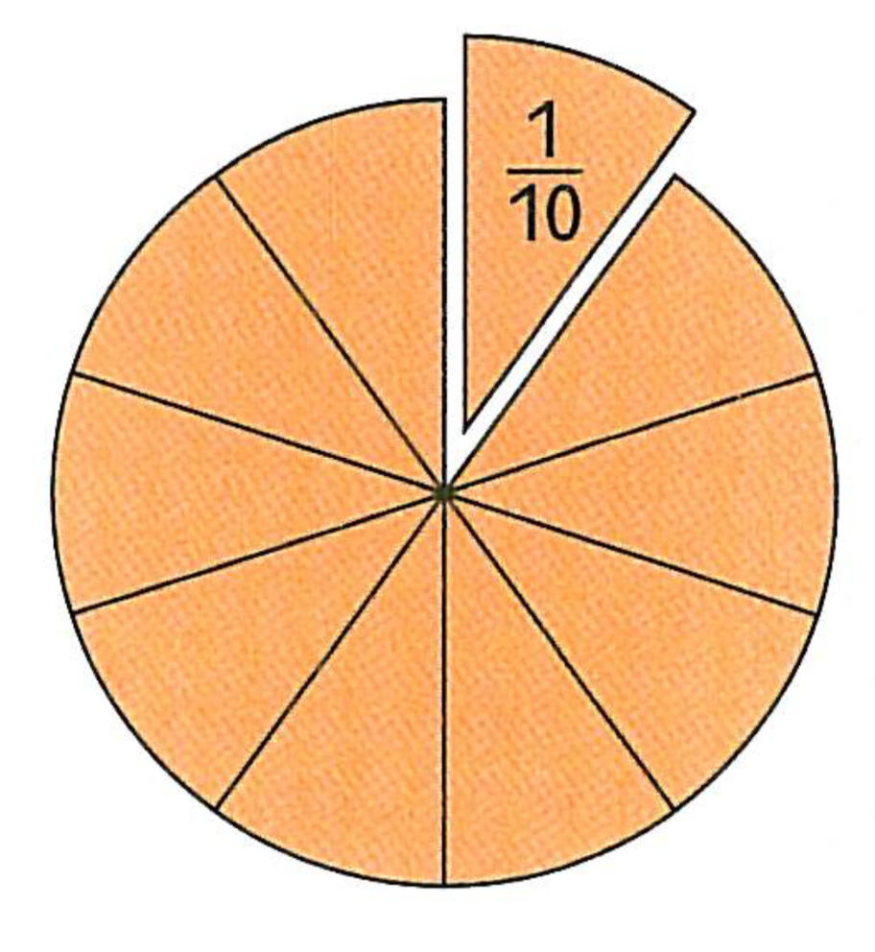

Setze aus verschiedenen Bruchteilen einen Kreis zusammen.

Zeichne drei verschiedene Lösungen

|  |  |  |  |
| --- | --- | --- | --- |
| **19.** | **Arithmetik: Brüche** | **S. 104** | **O/B** |

Was ist gleich? Verbinde die gleichgrossen Werte.

0.2 l 200ml 1/5 l 5dl

25dl 2dl 1/4l

½ l 500ml 0.5l