# Lernkontrolle 4 / 4. Schuljahr / Aufgabenangebot

# Thema: Multiplikation, Sachrechnen, Geometrie,

# Kontrollaufgaben ZB 4: S. 59 - 77

# UNBEDINGT AUFGABENAUSWAHL TREFFEN

|  |  |  |  |
| --- | --- | --- | --- |
| **1.** | **Arithmetik: Multiplikation** | **S. 59** | **M/D** |

Rechne auf deinem eigenen Weg

1. 39 • 77 **b**. 9 • 37037

|  |  |  |  |  |  |  |  |  |  |  |  |  |  |  |  |  |  |  |  |  |  |  |  |  |  |  |  |  |  |  |  |  |  |
| --- | --- | --- | --- | --- | --- | --- | --- | --- | --- | --- | --- | --- | --- | --- | --- | --- | --- | --- | --- | --- | --- | --- | --- | --- | --- | --- | --- | --- | --- | --- | --- | --- | --- |
|  |  |  |  |  |  |  |  |  |  |  |  |  |  |  |  |  |  |  |  |  |  |  |  |  |  |  |  |  |  |  |  |  |  |
|  |  |  |  |  |  |  |  |  |  |  |  |  |  |  |  |  |  |  |  |  |  |  |  |  |  |  |  |  |  |  |  |  |  |
|  |  |  |  |  |  |  |  |  |  |  |  |  |  |  |  |  |  |  |  |  |  |  |  |  |  |  |  |  |  |  |  |  |  |
|  |  |  |  |  |  |  |  |  |  |  |  |  |  |  |  |  |  |  |  |  |  |  |  |  |  |  |  |  |  |  |  |  |  |
|  |  |  |  |  |  |  |  |  |  |  |  |  |  |  |  |  |  |  |  |  |  |  |  |  |  |  |  |  |  |  |  |  |  |
|  |  |  |  |  |  |  |  |  |  |  |  |  |  |  |  |  |  |  |  |  |  |  |  |  |  |  |  |  |  |  |  |  |  |
|  |  |  |  |  |  |  |  |  |  |  |  |  |  |  |  |  |  |  |  |  |  |  |  |  |  |  |  |  |  |  |  |  |  |
|  |  |  |  |  |  |  |  |  |  |  |  |  |  |  |  |  |  |  |  |  |  |  |  |  |  |  |  |  |  |  |  |  |  |

|  |  |  |  |
| --- | --- | --- | --- |
| **2.** | **Arithmetik: Multiplikation** | **S. 59** | **M/D** |

Wie viele Stunden hat ein Monat. Berechne und schreibe deine Rechnung auf.

|  |  |  |  |  |  |  |  |  |  |  |  |  |  |  |  |  |  |  |  |  |  |  |  |  |  |  |  |  |  |  |  |  |  |
| --- | --- | --- | --- | --- | --- | --- | --- | --- | --- | --- | --- | --- | --- | --- | --- | --- | --- | --- | --- | --- | --- | --- | --- | --- | --- | --- | --- | --- | --- | --- | --- | --- | --- |
|  |  |  |  |  |  |  |  |  |  |  |  |  |  |  |  |  |  |  |  |  |  |  |  |  |  |  |  |  |  |  |  |  |  |
|  |  |  |  |  |  |  |  |  |  |  |  |  |  |  |  |  |  |  |  |  |  |  |  |  |  |  |  |  |  |  |  |  |  |
|  |  |  |  |  |  |  |  |  |  |  |  |  |  |  |  |  |  |  |  |  |  |  |  |  |  |  |  |  |  |  |  |  |  |
|  |  |  |  |  |  |  |  |  |  |  |  |  |  |  |  |  |  |  |  |  |  |  |  |  |  |  |  |  |  |  |  |  |  |
|  |  |  |  |  |  |  |  |  |  |  |  |  |  |  |  |  |  |  |  |  |  |  |  |  |  |  |  |  |  |  |  |  |  |
|  |  |  |  |  |  |  |  |  |  |  |  |  |  |  |  |  |  |  |  |  |  |  |  |  |  |  |  |  |  |  |  |  |  |
|  |  |  |  |  |  |  |  |  |  |  |  |  |  |  |  |  |  |  |  |  |  |  |  |  |  |  |  |  |  |  |  |  |  |
|  |  |  |  |  |  |  |  |  |  |  |  |  |  |  |  |  |  |  |  |  |  |  |  |  |  |  |  |  |  |  |  |  |  |

|  |  |  |  |
| --- | --- | --- | --- |
| **3.** | **Arithmetik: Multiplikation** | **S. 59** | **M/D** |

Rechne und prüfe mit gerundeten Zahlen. Beschreibe, was dir bei den Resultaten auffällt.

Versuche zu begründen.

3 • 746 3 • 646 3 • 546 3 • 446 3 • 346

|  |  |  |  |  |  |  |  |  |  |  |  |  |  |  |  |  |  |  |  |  |  |  |  |  |  |  |  |  |  |  |  |  |  |
| --- | --- | --- | --- | --- | --- | --- | --- | --- | --- | --- | --- | --- | --- | --- | --- | --- | --- | --- | --- | --- | --- | --- | --- | --- | --- | --- | --- | --- | --- | --- | --- | --- | --- |
|  |  |  |  |  |  |  |  |  |  |  |  |  |  |  |  |  |  |  |  |  |  |  |  |  |  |  |  |  |  |  |  |  |  |
|  |  |  |  |  |  |  |  |  |  |  |  |  |  |  |  |  |  |  |  |  |  |  |  |  |  |  |  |  |  |  |  |  |  |
|  |  |  |  |  |  |  |  |  |  |  |  |  |  |  |  |  |  |  |  |  |  |  |  |  |  |  |  |  |  |  |  |  |  |
|  |  |  |  |  |  |  |  |  |  |  |  |  |  |  |  |  |  |  |  |  |  |  |  |  |  |  |  |  |  |  |  |  |  |
|  |  |  |  |  |  |  |  |  |  |  |  |  |  |  |  |  |  |  |  |  |  |  |  |  |  |  |  |  |  |  |  |  |  |
|  |  |  |  |  |  |  |  |  |  |  |  |  |  |  |  |  |  |  |  |  |  |  |  |  |  |  |  |  |  |  |  |  |  |
|  |  |  |  |  |  |  |  |  |  |  |  |  |  |  |  |  |  |  |  |  |  |  |  |  |  |  |  |  |  |  |  |  |  |
|  |  |  |  |  |  |  |  |  |  |  |  |  |  |  |  |  |  |  |  |  |  |  |  |  |  |  |  |  |  |  |  |  |  |

|  |  |  |  |
| --- | --- | --- | --- |
| **4.** | **Arithmetik: Multiplikation** | **S. 59** | **M/D** |

Bilde aus den vier Ziffern **3, 5, 7 und 9** zwei zweistellige Zahlen und multipliziere sie.

Suche das kleinste und das grösste Ergebnis. Beschreibe deine Überlegungen.

|  |  |  |  |  |  |  |  |  |  |  |  |  |  |  |  |  |  |  |  |  |  |  |  |  |  |  |  |  |  |  |  |  |  |
| --- | --- | --- | --- | --- | --- | --- | --- | --- | --- | --- | --- | --- | --- | --- | --- | --- | --- | --- | --- | --- | --- | --- | --- | --- | --- | --- | --- | --- | --- | --- | --- | --- | --- |
|  |  |  |  |  |  |  |  |  |  |  |  |  |  |  |  |  |  |  |  |  |  |  |  |  |  |  |  |  |  |  |  |  |  |
|  |  |  |  |  |  |  |  |  |  |  |  |  |  |  |  |  |  |  |  |  |  |  |  |  |  |  |  |  |  |  |  |  |  |
|  |  |  |  |  |  |  |  |  |  |  |  |  |  |  |  |  |  |  |  |  |  |  |  |  |  |  |  |  |  |  |  |  |  |
|  |  |  |  |  |  |  |  |  |  |  |  |  |  |  |  |  |  |  |  |  |  |  |  |  |  |  |  |  |  |  |  |  |  |
|  |  |  |  |  |  |  |  |  |  |  |  |  |  |  |  |  |  |  |  |  |  |  |  |  |  |  |  |  |  |  |  |  |  |
|  |  |  |  |  |  |  |  |  |  |  |  |  |  |  |  |  |  |  |  |  |  |  |  |  |  |  |  |  |  |  |  |  |  |
|  |  |  |  |  |  |  |  |  |  |  |  |  |  |  |  |  |  |  |  |  |  |  |  |  |  |  |  |  |  |  |  |  |  |
|  |  |  |  |  |  |  |  |  |  |  |  |  |  |  |  |  |  |  |  |  |  |  |  |  |  |  |  |  |  |  |  |  |  |
|  |  |  |  |  |  |  |  |  |  |  |  |  |  |  |  |  |  |  |  |  |  |  |  |  |  |  |  |  |  |  |  |  |  |
|  |  |  |  |  |  |  |  |  |  |  |  |  |  |  |  |  |  |  |  |  |  |  |  |  |  |  |  |  |  |  |  |  |  |
|  |  |  |  |  |  |  |  |  |  |  |  |  |  |  |  |  |  |  |  |  |  |  |  |  |  |  |  |  |  |  |  |  |  |
|  |  |  |  |  |  |  |  |  |  |  |  |  |  |  |  |  |  |  |  |  |  |  |  |  |  |  |  |  |  |  |  |  |  |
|  |  |  |  |  |  |  |  |  |  |  |  |  |  |  |  |  |  |  |  |  |  |  |  |  |  |  |  |  |  |  |  |  |  |
|  |  |  |  |  |  |  |  |  |  |  |  |  |  |  |  |  |  |  |  |  |  |  |  |  |  |  |  |  |  |  |  |  |  |
|  |  |  |  |  |  |  |  |  |  |  |  |  |  |  |  |  |  |  |  |  |  |  |  |  |  |  |  |  |  |  |  |  |  |
|  |  |  |  |  |  |  |  |  |  |  |  |  |  |  |  |  |  |  |  |  |  |  |  |  |  |  |  |  |  |  |  |  |  |

|  |  |  |  |
| --- | --- | --- | --- |
| **5.** | **Arithmetik: Multiplikation** | **S. 59** | **M/D** |

Bilde aus den vier Ziffern **2, 4, 5, 7** zwei zweistellige Zahlen und multipliziere sie.

Suche ein Ergebnis, das kleiner ist als 2000. Findest du mehrere?

|  |  |  |  |  |  |  |  |  |  |  |  |  |  |  |  |  |  |  |  |  |  |  |  |  |  |  |  |  |  |  |  |  |  |
| --- | --- | --- | --- | --- | --- | --- | --- | --- | --- | --- | --- | --- | --- | --- | --- | --- | --- | --- | --- | --- | --- | --- | --- | --- | --- | --- | --- | --- | --- | --- | --- | --- | --- |
|  |  |  |  |  |  |  |  |  |  |  |  |  |  |  |  |  |  |  |  |  |  |  |  |  |  |  |  |  |  |  |  |  |  |
|  |  |  |  |  |  |  |  |  |  |  |  |  |  |  |  |  |  |  |  |  |  |  |  |  |  |  |  |  |  |  |  |  |  |
|  |  |  |  |  |  |  |  |  |  |  |  |  |  |  |  |  |  |  |  |  |  |  |  |  |  |  |  |  |  |  |  |  |  |
|  |  |  |  |  |  |  |  |  |  |  |  |  |  |  |  |  |  |  |  |  |  |  |  |  |  |  |  |  |  |  |  |  |  |
|  |  |  |  |  |  |  |  |  |  |  |  |  |  |  |  |  |  |  |  |  |  |  |  |  |  |  |  |  |  |  |  |  |  |
|  |  |  |  |  |  |  |  |  |  |  |  |  |  |  |  |  |  |  |  |  |  |  |  |  |  |  |  |  |  |  |  |  |  |
|  |  |  |  |  |  |  |  |  |  |  |  |  |  |  |  |  |  |  |  |  |  |  |  |  |  |  |  |  |  |  |  |  |  |
|  |  |  |  |  |  |  |  |  |  |  |  |  |  |  |  |  |  |  |  |  |  |  |  |  |  |  |  |  |  |  |  |  |  |
|  |  |  |  |  |  |  |  |  |  |  |  |  |  |  |  |  |  |  |  |  |  |  |  |  |  |  |  |  |  |  |  |  |  |
|  |  |  |  |  |  |  |  |  |  |  |  |  |  |  |  |  |  |  |  |  |  |  |  |  |  |  |  |  |  |  |  |  |  |
|  |  |  |  |  |  |  |  |  |  |  |  |  |  |  |  |  |  |  |  |  |  |  |  |  |  |  |  |  |  |  |  |  |  |
|  |  |  |  |  |  |  |  |  |  |  |  |  |  |  |  |  |  |  |  |  |  |  |  |  |  |  |  |  |  |  |  |  |  |
|  |  |  |  |  |  |  |  |  |  |  |  |  |  |  |  |  |  |  |  |  |  |  |  |  |  |  |  |  |  |  |  |  |  |
|  |  |  |  |  |  |  |  |  |  |  |  |  |  |  |  |  |  |  |  |  |  |  |  |  |  |  |  |  |  |  |  |  |  |
|  |  |  |  |  |  |  |  |  |  |  |  |  |  |  |  |  |  |  |  |  |  |  |  |  |  |  |  |  |  |  |  |  |  |
|  |  |  |  |  |  |  |  |  |  |  |  |  |  |  |  |  |  |  |  |  |  |  |  |  |  |  |  |  |  |  |  |  |  |

|  |  |  |  |
| --- | --- | --- | --- |
| **6.** | **Sachrechnen: Schulwege** | **S. 63** | **M/D** |

Die Kinder haben ihre Schulwege gemessen.

|  |  |  |  |  |  |
| --- | --- | --- | --- | --- | --- |
| **Regula** | **Claudine** | **Yves** | **Rahel** | **Nicole** | **Andrea** |
| 535 m | 805 m | 345 m | 725 m | 215 m | 1 230 m |

Bestimme den kürzesten und den längsten Weg und berechne den Unterschied.   
Schreibe deine Rechnung auf.

|  |  |  |  |  |  |  |  |  |  |  |  |  |  |  |  |  |  |  |  |  |  |  |  |  |  |  |  |  |  |  |  |  |  |
| --- | --- | --- | --- | --- | --- | --- | --- | --- | --- | --- | --- | --- | --- | --- | --- | --- | --- | --- | --- | --- | --- | --- | --- | --- | --- | --- | --- | --- | --- | --- | --- | --- | --- |
|  |  |  |  |  |  |  |  |  |  |  |  |  |  |  |  |  |  |  |  |  |  |  |  |  |  |  |  |  |  |  |  |  |  |
|  |  |  |  |  |  |  |  |  |  |  |  |  |  |  |  |  |  |  |  |  |  |  |  |  |  |  |  |  |  |  |  |  |  |
|  |  |  |  |  |  |  |  |  |  |  |  |  |  |  |  |  |  |  |  |  |  |  |  |  |  |  |  |  |  |  |  |  |  |
|  |  |  |  |  |  |  |  |  |  |  |  |  |  |  |  |  |  |  |  |  |  |  |  |  |  |  |  |  |  |  |  |  |  |
|  |  |  |  |  |  |  |  |  |  |  |  |  |  |  |  |  |  |  |  |  |  |  |  |  |  |  |  |  |  |  |  |  |  |
|  |  |  |  |  |  |  |  |  |  |  |  |  |  |  |  |  |  |  |  |  |  |  |  |  |  |  |  |  |  |  |  |  |  |
|  |  |  |  |  |  |  |  |  |  |  |  |  |  |  |  |  |  |  |  |  |  |  |  |  |  |  |  |  |  |  |  |  |  |

|  |  |  |  |
| --- | --- | --- | --- |
| **7.** | **Sachrechnen: Schulwege** | **S. 63** | **M/D** |

Die Kinder haben ihre Schulwege gemessen.

|  |  |  |  |  |  |
| --- | --- | --- | --- | --- | --- |
| **Regula** | **Claudine** | **Yves** | **Rahel** | **Nicole** | **Andrea** |
| 535 m | 805 m | 345 m | 725 m | 215 m | 1230 m |

Wähle zwei Kinder aus. Berechne die Mitte der beiden Schulwege.

Beispiel: Nicole: 215m und Yves: 345m 🡪 die Mitte: 280m

Mache 2 weitere Beispiele.

|  |  |  |  |  |  |  |  |  |  |  |  |  |  |  |  |  |  |  |  |  |  |  |  |  |  |  |  |  |  |  |  |  |  |
| --- | --- | --- | --- | --- | --- | --- | --- | --- | --- | --- | --- | --- | --- | --- | --- | --- | --- | --- | --- | --- | --- | --- | --- | --- | --- | --- | --- | --- | --- | --- | --- | --- | --- |
|  |  |  |  |  |  |  |  |  |  |  |  |  |  |  |  |  |  |  |  |  |  |  |  |  |  |  |  |  |  |  |  |  |  |
|  |  |  |  |  |  |  |  |  |  |  |  |  |  |  |  |  |  |  |  |  |  |  |  |  |  |  |  |  |  |  |  |  |  |
|  |  |  |  |  |  |  |  |  |  |  |  |  |  |  |  |  |  |  |  |  |  |  |  |  |  |  |  |  |  |  |  |  |  |
|  |  |  |  |  |  |  |  |  |  |  |  |  |  |  |  |  |  |  |  |  |  |  |  |  |  |  |  |  |  |  |  |  |  |
|  |  |  |  |  |  |  |  |  |  |  |  |  |  |  |  |  |  |  |  |  |  |  |  |  |  |  |  |  |  |  |  |  |  |
|  |  |  |  |  |  |  |  |  |  |  |  |  |  |  |  |  |  |  |  |  |  |  |  |  |  |  |  |  |  |  |  |  |  |
|  |  |  |  |  |  |  |  |  |  |  |  |  |  |  |  |  |  |  |  |  |  |  |  |  |  |  |  |  |  |  |  |  |  |
|  |  |  |  |  |  |  |  |  |  |  |  |  |  |  |  |  |  |  |  |  |  |  |  |  |  |  |  |  |  |  |  |  |  |

|  |  |  |  |
| --- | --- | --- | --- |
| **8.** | **Sachrechnen: Schulwege** | **S. 63** | **M/D** |

Die Kinder haben ihre Schulwege gemessen und die Zeit festgehalten.

|  |  |  |  |  |  |
| --- | --- | --- | --- | --- | --- |
| **Regula** | **Claudine** | **Yves** | **Rahel** | **Nicole** | **Andrea** |
| 535 m | 805 m | 345 m | 725 m | 215 m | 1 230 m |
| 8 min | 18 min | 13 min | 16 min | 5 min | 21 min |

1. Wie viele Kilometer und Meter legt Rahel in einer Woche zurück?
2. Wie viele h und min ist Rahel in einer Woche auf dem Schulweg unterwegs?

Schreibe deine Überlegungen und Rechnungen auf.

|  |  |  |  |  |  |  |  |  |  |  |  |  |  |  |  |  |  |  |  |  |  |  |  |  |  |  |  |  |  |  |  |  |  |
| --- | --- | --- | --- | --- | --- | --- | --- | --- | --- | --- | --- | --- | --- | --- | --- | --- | --- | --- | --- | --- | --- | --- | --- | --- | --- | --- | --- | --- | --- | --- | --- | --- | --- |
|  |  |  |  |  |  |  |  |  |  |  |  |  |  |  |  |  |  |  |  |  |  |  |  |  |  |  |  |  |  |  |  |  |  |
|  |  |  |  |  |  |  |  |  |  |  |  |  |  |  |  |  |  |  |  |  |  |  |  |  |  |  |  |  |  |  |  |  |  |
|  |  |  |  |  |  |  |  |  |  |  |  |  |  |  |  |  |  |  |  |  |  |  |  |  |  |  |  |  |  |  |  |  |  |
|  |  |  |  |  |  |  |  |  |  |  |  |  |  |  |  |  |  |  |  |  |  |  |  |  |  |  |  |  |  |  |  |  |  |
|  |  |  |  |  |  |  |  |  |  |  |  |  |  |  |  |  |  |  |  |  |  |  |  |  |  |  |  |  |  |  |  |  |  |
|  |  |  |  |  |  |  |  |  |  |  |  |  |  |  |  |  |  |  |  |  |  |  |  |  |  |  |  |  |  |  |  |  |  |
|  |  |  |  |  |  |  |  |  |  |  |  |  |  |  |  |  |  |  |  |  |  |  |  |  |  |  |  |  |  |  |  |  |  |
|  |  |  |  |  |  |  |  |  |  |  |  |  |  |  |  |  |  |  |  |  |  |  |  |  |  |  |  |  |  |  |  |  |  |

|  |  |  |  |
| --- | --- | --- | --- |
| **9.** | **Sachrechnen: Einzelpreis - Gesamtpreis** | **S. 64 / 65** | **M/D** |

|  |  |  |  |  |  |  |  |  |  |  |  |  |  |  |  |  |  |  |  |  |
| --- | --- | --- | --- | --- | --- | --- | --- | --- | --- | --- | --- | --- | --- | --- | --- | --- | --- | --- | --- | --- |
| Ergänze die Preistabelle.   |  |  |  |  |  |  |  |  |  |  | | --- | --- | --- | --- | --- | --- | --- | --- | --- | --- | | 1000g | 750g | 625g | 500g | 400g | 375g | 300g | 100g | 50g | 25g | | 22.- |  |  |  |  |  |  |  |  |  | |

|  |  |  |  |
| --- | --- | --- | --- |
| **10.** | **Sachrechnen: Einzelpreis - Gesamtpreis** | **S. 64 / 65** | **M/D** |

Ergänze die Preistabelle.

**Bergkäse**

|  |  |  |  |  |  |
| --- | --- | --- | --- | --- | --- |
| **Gewicht** | 100 g | 200g | 400g | 800 g | 1 kg |
| **Preis** |  | 5.60 Fr. |  |  |  |

|  |  |  |  |
| --- | --- | --- | --- |
| **11.** | **Sachrechnen: Einzelpreis - Gesamtpreis** | **S. 64 / 65** | **M/D** |

Ergänze die Preistabelle.

**Holländischer Gouda**

|  |  |  |  |  |  |
| --- | --- | --- | --- | --- | --- |
| **Gewicht** | 25 g | 100g | 425g | 675 g | 1 kg |
| **Preis** |  | 2 Fr. |  |  |  |

|  |  |  |  |
| --- | --- | --- | --- |
| **12.** | **Geometrie: Grundrisse und Seitenansichten** | **S. 66 / 67** | **M/D** |

Markiere auf jedem Plan das höchste Gebäude.

a. b. c.

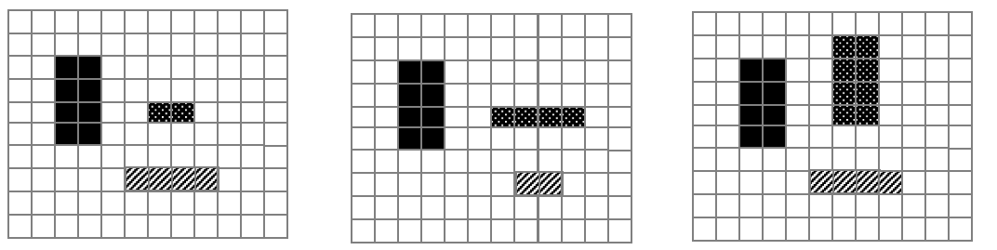

|  |  |  |  |
| --- | --- | --- | --- |
| **13.** | **Geometrie: Seitenansichten** | **S. 66 / 67** | **M/D** |

Aus welcher Richtung siehst du diese zwei Seitenansichten?

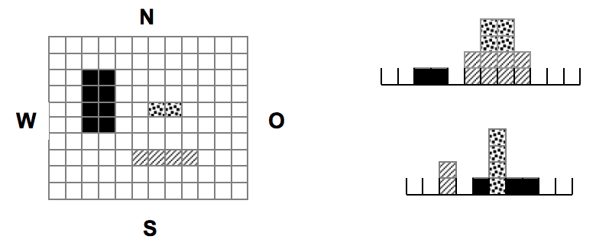

von ___________

von ___________

|  |  |  |  |
| --- | --- | --- | --- |
| **14.** | **Geometrie: Seitenansichten** | **S. 66 / 67** | **M/D** |

|  |  |  |  |  |  |  |  |  |  |  |  |  |  |  |  |  |  |  |  |  |  |  |  |  |  |  |  |  |  |  |  |  |  |  |  |  |  |  |  |  |  |  |  |  |  |  |  |  |
| --- | --- | --- | --- | --- | --- | --- | --- | --- | --- | --- | --- | --- | --- | --- | --- | --- | --- | --- | --- | --- | --- | --- | --- | --- | --- | --- | --- | --- | --- | --- | --- | --- | --- | --- | --- | --- | --- | --- | --- | --- | --- | --- | --- | --- | --- | --- | --- | --- |
| Zeichne die zwei Seitenansichten von Süden und von Osten.  Von Norden:   |  |  |  |  |  |  |  |  |  |  |  |  | | --- | --- | --- | --- | --- | --- | --- | --- | --- | --- | --- | --- | |  |  |  |  |  |  |  |  |  |  |  |  | |  |  |  |  |  |  |  |  |  |  |  |  | |  |  |  |  |  |  |  |  |  |  |  |  | |  |  |  |  |  |  |  |  |  |  |  |  | |
| Von Osten:   |  |  |  |  |  |  |  |  |  |  |  |  | | --- | --- | --- | --- | --- | --- | --- | --- | --- | --- | --- | --- | |  |  |  |  |  |  |  |  |  |  |  |  | |  |  |  |  |  |  |  |  |  |  |  |  | |  |  |  |  |  |  |  |  |  |  |  |  | |  |  |  |  |  |  |  |  |  |  |  |  | |

|  |  |  |  |
| --- | --- | --- | --- |
| **15.** | **Sachrechnen: Im Einkaufszentrum** | **S. 70** | **M/D** |

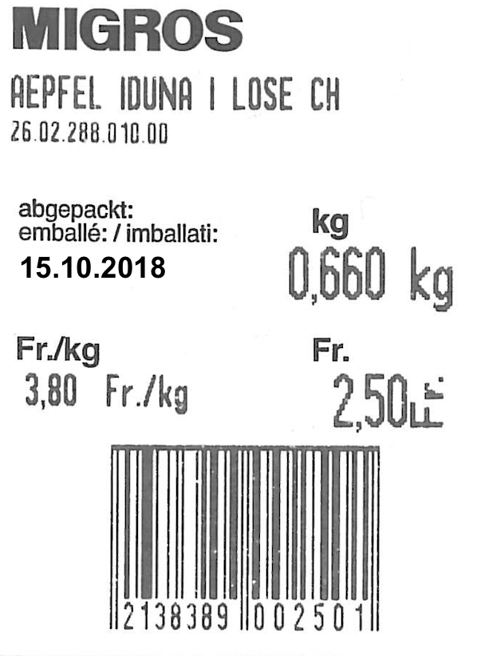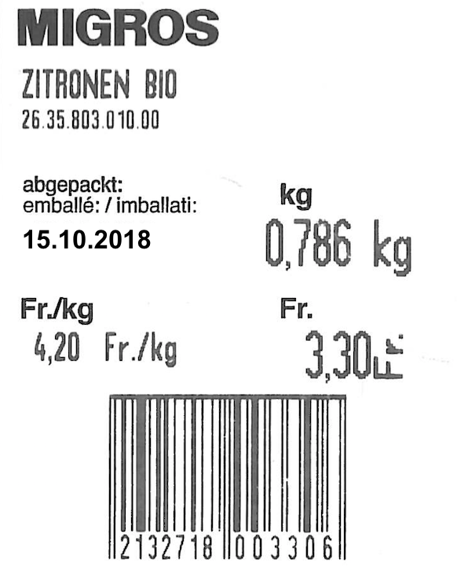

1. Wie viel kostet jeweils 1kg der beiden Früchte? …………………………………………………
2. Wie viel bezahlst du, wenn du diese zwei Früchte einkaufst? …………………………………………………
3. Wann hast du diesen Einkauf gemacht? (Tag, Monat und Jahr) …………………………………………………

|  |  |  |  |
| --- | --- | --- | --- |
| **16.** | **Sachrechnen: Im Einkaufszentrum** | **S. 71** | **M/D** |



–.60 Fr. –.90 Fr. 1.25 Fr. 1.80 Fr.

Vergleiche bei zwei die Angebote .Was fällt dir auf? Begründe deine Feststellungen.

|  |  |  |  |  |  |  |  |  |  |  |  |  |  |  |  |  |  |  |  |  |  |  |  |  |  |  |  |  |  |  |  |  |  |
| --- | --- | --- | --- | --- | --- | --- | --- | --- | --- | --- | --- | --- | --- | --- | --- | --- | --- | --- | --- | --- | --- | --- | --- | --- | --- | --- | --- | --- | --- | --- | --- | --- | --- |
|  |  |  |  |  |  |  |  |  |  |  |  |  |  |  |  |  |  |  |  |  |  |  |  |  |  |  |  |  |  |  |  |  |  |
|  |  |  |  |  |  |  |  |  |  |  |  |  |  |  |  |  |  |  |  |  |  |  |  |  |  |  |  |  |  |  |  |  |  |
|  |  |  |  |  |  |  |  |  |  |  |  |  |  |  |  |  |  |  |  |  |  |  |  |  |  |  |  |  |  |  |  |  |  |
|  |  |  |  |  |  |  |  |  |  |  |  |  |  |  |  |  |  |  |  |  |  |  |  |  |  |  |  |  |  |  |  |  |  |
|  |  |  |  |  |  |  |  |  |  |  |  |  |  |  |  |  |  |  |  |  |  |  |  |  |  |  |  |  |  |  |  |  |  |
|  |  |  |  |  |  |  |  |  |  |  |  |  |  |  |  |  |  |  |  |  |  |  |  |  |  |  |  |  |  |  |  |  |  |
|  |  |  |  |  |  |  |  |  |  |  |  |  |  |  |  |  |  |  |  |  |  |  |  |  |  |  |  |  |  |  |  |  |  |
|  |  |  |  |  |  |  |  |  |  |  |  |  |  |  |  |  |  |  |  |  |  |  |  |  |  |  |  |  |  |  |  |  |  |

|  |  |  |  |
| --- | --- | --- | --- |
| **17.** | **Geometrie: Vergrössern und verkleinern** | **S. 72 / 73** | **M/D** |

Vergrössere das Wort im

Massstab 2:1.

Das Wort wird zweimal so gross

|  |  |  |  |
| --- | --- | --- | --- |
| **18.** | **Geometrie: Vergrössern und verkleinern** | **S. 72 / 73** |  |

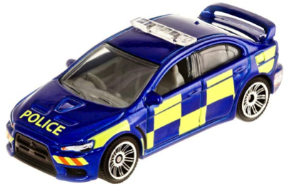

Das Modellauto ist im Massstab 1:50 verkleinert.

Es ist 7 cm lang und 4 cm breit.

Wie lang und breit ist das Auto in Wirklichkeit?

|  |  |  |  |  |  |  |  |  |  |  |  |  |  |  |  |  |  |  |  |  |  |  |  |  |  |  |  |  |  |
| --- | --- | --- | --- | --- | --- | --- | --- | --- | --- | --- | --- | --- | --- | --- | --- | --- | --- | --- | --- | --- | --- | --- | --- | --- | --- | --- | --- | --- | --- |
|  |  |  |  |  |  |  |  |  |  |  |  |  |  |  |  |  |  |  |  |  |  |  |  |  |  |  |  |  |  |
|  |  |  |  |  |  |  |  |  |  |  |  |  |  |  |  |  |  |  |  |  |  |  |  |  |  |  |  |  |  |
|  |  |  |  |  |  |  |  |  |  |  |  |  |  |  |  |  |  |  |  |  |  |  |  |  |  |  |  |  |  |
|  |  |  |  |  |  |  |  |  |  |  |  |  |  |  |  |  |  |  |  |  |  |  |  |  |  |  |  |  |  |
|  |  |  |  |  |  |  |  |  |  |  |  |  |  |  |  |  |  |  |  |  |  |  |  |  |  |  |  |  |  |
|  |  |  |  |  |  |  |  |  |  |  |  |  |  |  |  |  |  |  |  |  |  |  |  |  |  |  |  |  |  |
|  |  |  |  |  |  |  |  |  |  |  |  |  |  |  |  |  |  |  |  |  |  |  |  |  |  |  |  |  |  |
|  |  |  |  |  |  |  |  |  |  |  |  |  |  |  |  |  |  |  |  |  |  |  |  |  |  |  |  |  |  |
|  |  |  |  |  |  |  |  |  |  |  |  |  |  |  |  |  |  |  |  |  |  |  |  |  |  |  |  |  |  |

|  |  |  |  |
| --- | --- | --- | --- |
| **19.** | **Sachrechnen: Preislisten erstellen** | **S. 74** | **M/D** |

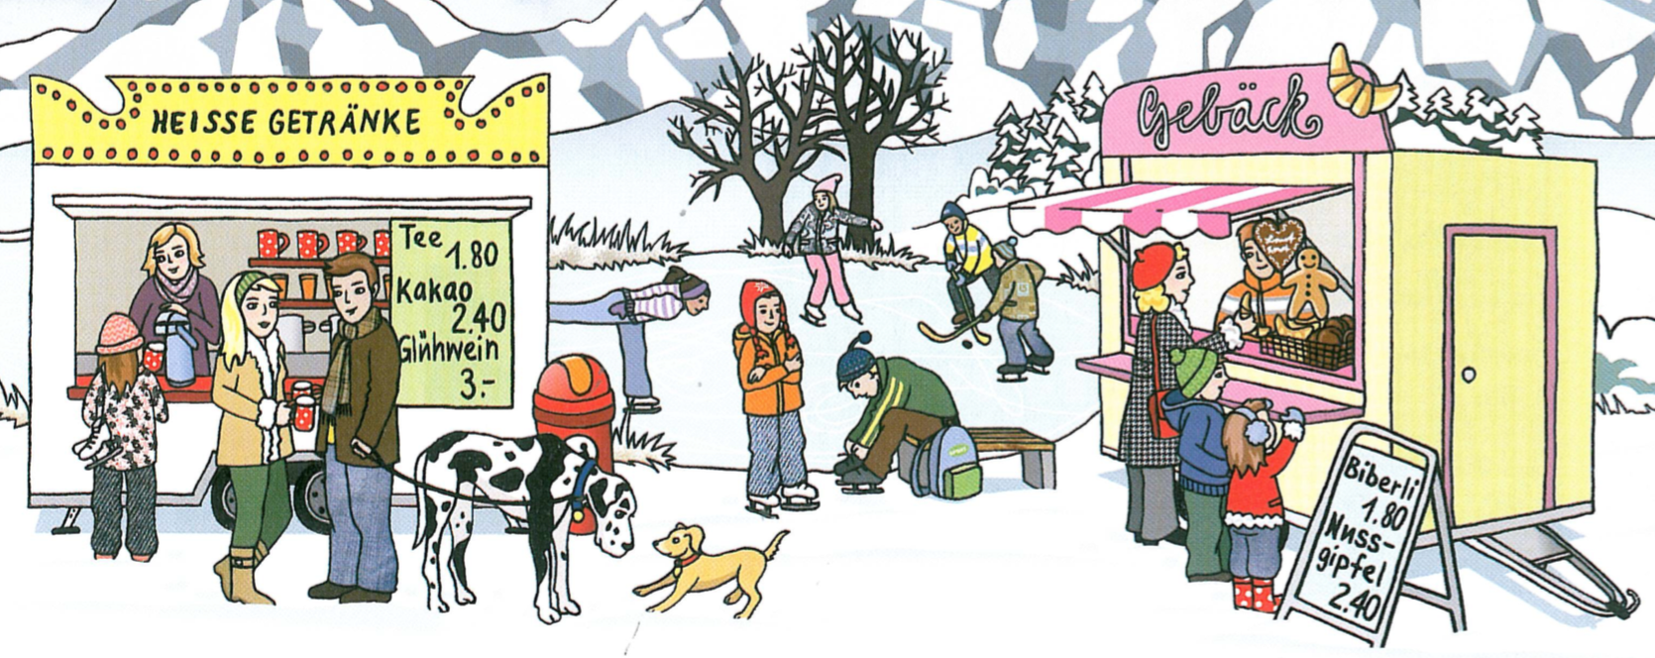

1. Schreibe eine Preisliste für Biberli. (1- 10 Stück)
2. Du hast 20.- im Portemonnaie. Du bist mit 3 Kollegen/ Kolleginnen am Schlittschuhlaufen.   
   Kaufe für alle ein Getränk und ein Gebäck.

|  |  |  |  |  |  |  |  |  |  |  |  |  |  |  |  |  |  |  |  |  |  |  |  |  |  |  |  |  |  |
| --- | --- | --- | --- | --- | --- | --- | --- | --- | --- | --- | --- | --- | --- | --- | --- | --- | --- | --- | --- | --- | --- | --- | --- | --- | --- | --- | --- | --- | --- |
|  |  |  |  |  |  |  |  |  |  |  |  |  |  |  |  |  |  |  |  |  |  |  |  |  |  |  |  |  |  |
|  |  |  |  |  |  |  |  |  |  |  |  |  |  |  |  |  |  |  |  |  |  |  |  |  |  |  |  |  |  |
|  |  |  |  |  |  |  |  |  |  |  |  |  |  |  |  |  |  |  |  |  |  |  |  |  |  |  |  |  |  |
|  |  |  |  |  |  |  |  |  |  |  |  |  |  |  |  |  |  |  |  |  |  |  |  |  |  |  |  |  |  |
|  |  |  |  |  |  |  |  |  |  |  |  |  |  |  |  |  |  |  |  |  |  |  |  |  |  |  |  |  |  |
|  |  |  |  |  |  |  |  |  |  |  |  |  |  |  |  |  |  |  |  |  |  |  |  |  |  |  |  |  |  |
|  |  |  |  |  |  |  |  |  |  |  |  |  |  |  |  |  |  |  |  |  |  |  |  |  |  |  |  |  |  |
|  |  |  |  |  |  |  |  |  |  |  |  |  |  |  |  |  |  |  |  |  |  |  |  |  |  |  |  |  |  |
|  |  |  |  |  |  |  |  |  |  |  |  |  |  |  |  |  |  |  |  |  |  |  |  |  |  |  |  |  |  |
|  |  |  |  |  |  |  |  |  |  |  |  |  |  |  |  |  |  |  |  |  |  |  |  |  |  |  |  |  |  |
|  |  |  |  |  |  |  |  |  |  |  |  |  |  |  |  |  |  |  |  |  |  |  |  |  |  |  |  |  |  |

|  |  |  |  |
| --- | --- | --- | --- |
| **20.** | **Sachrechnen: Überlegen und ausprobieren** | **S. 75** | **M/D** |

Im Zoo werden in einem Gehege 16 Tiere gezählt. Es sind Pelikane und Ziegen.

Zusammen haben sie 58 Beine. Wie viele Pelikane und wie viele Ziegen sind es?

|  |  |  |  |  |  |  |  |  |  |  |  |  |  |  |  |  |  |  |  |  |  |  |  |  |  |  |  |  |  |
| --- | --- | --- | --- | --- | --- | --- | --- | --- | --- | --- | --- | --- | --- | --- | --- | --- | --- | --- | --- | --- | --- | --- | --- | --- | --- | --- | --- | --- | --- |
|  |  |  |  |  |  |  |  |  |  |  |  |  |  |  |  |  |  |  |  |  |  |  |  |  |  |  |  |  |  |
|  |  |  |  |  |  |  |  |  |  |  |  |  |  |  |  |  |  |  |  |  |  |  |  |  |  |  |  |  |  |
|  |  |  |  |  |  |  |  |  |  |  |  |  |  |  |  |  |  |  |  |  |  |  |  |  |  |  |  |  |  |
|  |  |  |  |  |  |  |  |  |  |  |  |  |  |  |  |  |  |  |  |  |  |  |  |  |  |  |  |  |  |
|  |  |  |  |  |  |  |  |  |  |  |  |  |  |  |  |  |  |  |  |  |  |  |  |  |  |  |  |  |  |
|  |  |  |  |  |  |  |  |  |  |  |  |  |  |  |  |  |  |  |  |  |  |  |  |  |  |  |  |  |  |
|  |  |  |  |  |  |  |  |  |  |  |  |  |  |  |  |  |  |  |  |  |  |  |  |  |  |  |  |  |  |
|  |  |  |  |  |  |  |  |  |  |  |  |  |  |  |  |  |  |  |  |  |  |  |  |  |  |  |  |  |  |
|  |  |  |  |  |  |  |  |  |  |  |  |  |  |  |  |  |  |  |  |  |  |  |  |  |  |  |  |  |  |
|  |  |  |  |  |  |  |  |  |  |  |  |  |  |  |  |  |  |  |  |  |  |  |  |  |  |  |  |  |  |
|  |  |  |  |  |  |  |  |  |  |  |  |  |  |  |  |  |  |  |  |  |  |  |  |  |  |  |  |  |  |
|  |  |  |  |  |  |  |  |  |  |  |  |  |  |  |  |  |  |  |  |  |  |  |  |  |  |  |  |  |  |
|  |  |  |  |  |  |  |  |  |  |  |  |  |  |  |  |  |  |  |  |  |  |  |  |  |  |  |  |  |  |
|  |  |  |  |  |  |  |  |  |  |  |  |  |  |  |  |  |  |  |  |  |  |  |  |  |  |  |  |  |  |
|  |  |  |  |  |  |  |  |  |  |  |  |  |  |  |  |  |  |  |  |  |  |  |  |  |  |  |  |  |  |
|  |  |  |  |  |  |  |  |  |  |  |  |  |  |  |  |  |  |  |  |  |  |  |  |  |  |  |  |  |  |

|  |  |  |  |
| --- | --- | --- | --- |
| **21.** | **Sachrechnen: Tageslängen** | **S. 76 / 77** | **M/D** |

|  |  |  |  |  |  |  |  |  |  |  |  |  |  |  |  |  |  |  |  |  |  |  |  |  |  |  |  |  |  |  |  |  |  |  |  |  |  |  |  |  |  |  |  |  |  |
| --- | --- | --- | --- | --- | --- | --- | --- | --- | --- | --- | --- | --- | --- | --- | --- | --- | --- | --- | --- | --- | --- | --- | --- | --- | --- | --- | --- | --- | --- | --- | --- | --- | --- | --- | --- | --- | --- | --- | --- | --- | --- | --- | --- | --- | --- |
| Berechne die Tageslängen in Stunden (h) und Minuten (min).   |  |  |  |  | | --- | --- | --- | --- | | **Datum** | **Sonnenaufgang** | **Sonnenuntergang** | **Tageslänge** | | 21. März | 06.27 Uhr | 18.40 Uhr |  | | 21. Dezember | 08.11 Uhr | 16.37 Uhr |  | | 21. Juni | 05.28 Uhr | 21.27 Uhr |  |   Schreibe oder zeichne deine Überlegungen auf. | | | | | | | | | | | | | | | | | | | | | | | | | | | | | |
|  |  |  |  |  |  |  |  |  |  |  |  |  |  |  |  |  |  |  |  |  |  |  |  |  |  |  |  |  |  | |
|  |  |  |  |  |  |  |  |  |  |  |  |  |  |  |  |  |  |  |  |  |  |  |  |  |  |  |  |  |  | |
|  |  |  |  |  |  |  |  |  |  |  |  |  |  |  |  |  |  |  |  |  |  |  |  |  |  |  |  |  |  | |
|  |  |  |  |  |  |  |  |  |  |  |  |  |  |  |  |  |  |  |  |  |  |  |  |  |  |  |  |  |  | |
|  |  |  |  |  |  |  |  |  |  |  |  |  |  |  |  |  |  |  |  |  |  |  |  |  |  |  |  |  |  | |
|  |  |  |  |  |  |  |  |  |  |  |  |  |  |  |  |  |  |  |  |  |  |  |  |  |  |  |  |  |  | |
|  |  |  |  |  |  |  |  |  |  |  |  |  |  |  |  |  |  |  |  |  |  |  |  |  |  |  |  |  |  | |
|  |  |  |  |  |  |  |  |  |  |  |  |  |  |  |  |  |  |  |  |  |  |  |  |  |  |  |  |  |  | |
|  |  |  |  |  |  |  |  |  |  |  |  |  |  |  |  |  |  |  |  |  |  |  |  |  |  |  |  |  |  | |