

|  |  |
| --- | --- |
| Forscherauftrag: **Zug fahren** | Name: ………………… |



**Der schnellste Zug der Welt fährt 600 Stundenkilometer**

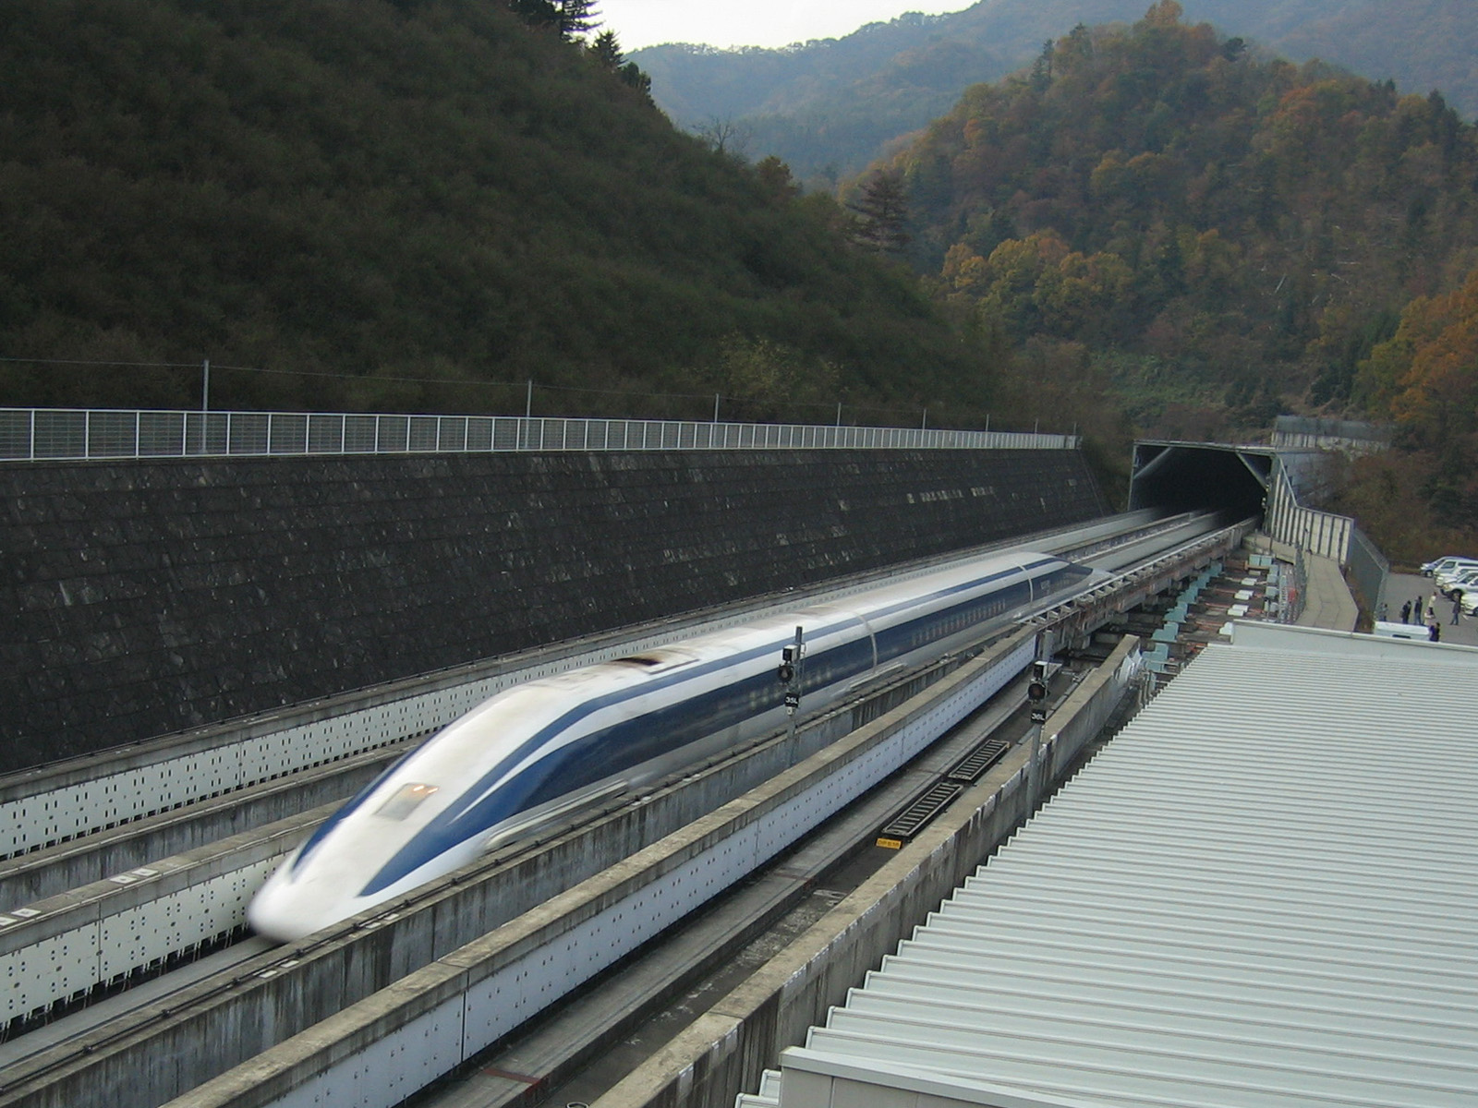So schnell wie die japanische Magnetschwebebahn ist kein anderer Zug rund um den Globus. Auf einer Teststrecke durchbrach ein Zug namens «Maglev» eine Geschwindigkeit von knapp über 600 Kilometern pro Stunde, eine bislang unerreichte Marke. Der Inselstaat Japan hat eines der dichtesten Schienennetze der Welt. Hochgeschwindigkeitszüge, von denen andernorts nicht einmal geträumt werden darf, sind dort längst Alltag.

|  |  |  |  |
| --- | --- | --- | --- |
| /var/folders/0j/jqy21yqn48x001j4tdl0rw1r0000gp/T/com.microsoft.Word/WebArchiveCopyPasteTempFiles/Presentation-du-nouveau-TGV-Duplex-3-e-generation-a-la-gare-Champ.jpg | de_ice3_ffm2_gr | icn_zug_gr | it_etr500_mailand4_gr |
| TGV Atlantique  Frankreich  Durchschnitt: 240 km/h  Maximal: 300 km/h | ICE 3  Deutschland  Durchschnitt: 225 km/h  Maximal: 330 km/h | ICN  Schweiz  Durchschnitt: 200 km/h  Maximal: 220 km/h | Pendolino  Italien  Durchschnitt: 220 km/h  Maximal: 280 km/h |

**Die SBB**

Die Schweizerische Bundesbahn SBB befördert mit täglich 4700 Zügen jährlich über 450 Millionen Personen und über 50 Millionen Tonnen Güter. Die Reisezüge legen jährlich etwa 150 Millionen Kilometer zurück. Mit rund 20 Millionen Tonnen im Jahr ist der

alpenquerender Güterverkehr durch den Gotthard die am stärkste befahrene Gütertransitachse über die Alpen. Über 3 Millionen Menschen besitzen ein Halbtaxabonnement, knapp 500‘000 Personen nutzen mit dem Generalabonnement die freie Fahrt auf Bahnen, Schiffen und Bussen.

Das Schienennetz hat eine gesamte Länge von über 5000 km und bedient 1842 Haltestellen. 3007 Streckenkilometer gehören den SBB, 245 km der BLS, den Rest teilen sich 49 Bahnunternehmungen. Im schweizerischen Mittel unternimmt jede Person jährlich 47 Bahnfahrten von durchschnittlich 42 km Länge.

Schreibe deine Fragestellungen und deine Berechnungen auf.

|  |  |  |  |  |  |  |  |  |  |  |  |  |  |  |  |  |  |  |  |  |  |  |  |  |  |  |  |  |  |  |  |  |  |  |  |
| --- | --- | --- | --- | --- | --- | --- | --- | --- | --- | --- | --- | --- | --- | --- | --- | --- | --- | --- | --- | --- | --- | --- | --- | --- | --- | --- | --- | --- | --- | --- | --- | --- | --- | --- | --- |
|  |  |  |  |  |  |  |  |  |  |  |  |  |  |  |  |  |  |  |  |  |  |  |  |  |  |  |  |  |  |  |  |  |  |  |  |
|  |  |  |  |  |  |  |  |  |  |  |  |  |  |  |  |  |  |  |  |  |  |  |  |  |  |  |  |  |  |  |  |  |  |  |  |
|  |  |  |  |  |  |  |  |  |  |  |  |  |  |  |  |  |  |  |  |  |  |  |  |  |  |  |  |  |  |  |  |  |  |  |  |
|  |  |  |  |  |  |  |  |  |  |  |  |  |  |  |  |  |  |  |  |  |  |  |  |  |  |  |  |  |  |  |  |  |  |  |  |
|  |  |  |  |  |  |  |  |  |  |  |  |  |  |  |  |  |  |  |  |  |  |  |  |  |  |  |  |  |  |  |  |  |  |  |  |
|  |  |  |  |  |  |  |  |  |  |  |  |  |  |  |  |  |  |  |  |  |  |  |  |  |  |  |  |  |  |  |  |  |  |  |  |
|  |  |  |  |  |  |  |  |  |  |  |  |  |  |  |  |  |  |  |  |  |  |  |  |  |  |  |  |  |  |  |  |  |  |  |  |
|  |  |  |  |  |  |  |  |  |  |  |  |  |  |  |  |  |  |  |  |  |  |  |  |  |  |  |  |  |  |  |  |  |  |  |  |
|  |  |  |  |  |  |  |  |  |  |  |  |  |  |  |  |  |  |  |  |  |  |  |  |  |  |  |  |  |  |  |  |  |  |  |  |
|  |  |  |  |  |  |  |  |  |  |  |  |  |  |  |  |  |  |  |  |  |  |  |  |  |  |  |  |  |  |  |  |  |  |  |  |
|  |  |  |  |  |  |  |  |  |  |  |  |  |  |  |  |  |  |  |  |  |  |  |  |  |  |  |  |  |  |  |  |  |  |  |  |
|  |  |  |  |  |  |  |  |  |  |  |  |  |  |  |  |  |  |  |  |  |  |  |  |  |  |  |  |  |  |  |  |  |  |  |  |
|  |  |  |  |  |  |  |  |  |  |  |  |  |  |  |  |  |  |  |  |  |  |  |  |  |  |  |  |  |  |  |  |  |  |  |  |
|  |  |  |  |  |  |  |  |  |  |  |  |  |  |  |  |  |  |  |  |  |  |  |  |  |  |  |  |  |  |  |  |  |  |  |  |
|  |  |  |  |  |  |  |  |  |  |  |  |  |  |  |  |  |  |  |  |  |  |  |  |  |  |  |  |  |  |  |  |  |  |  |  |
|  |  |  |  |  |  |  |  |  |  |  |  |  |  |  |  |  |  |  |  |  |  |  |  |  |  |  |  |  |  |  |  |  |  |  |  |
|  |  |  |  |  |  |  |  |  |  |  |  |  |  |  |  |  |  |  |  |  |  |  |  |  |  |  |  |  |  |  |  |  |  |  |  |
|  |  |  |  |  |  |  |  |  |  |  |  |  |  |  |  |  |  |  |  |  |  |  |  |  |  |  |  |  |  |  |  |  |  |  |  |
|  |  |  |  |  |  |  |  |  |  |  |  |  |  |  |  |  |  |  |  |  |  |  |  |  |  |  |  |  |  |  |  |  |  |  |  |
|  |  |  |  |  |  |  |  |  |  |  |  |  |  |  |  |  |  |  |  |  |  |  |  |  |  |  |  |  |  |  |  |  |  |  |  |
|  |  |  |  |  |  |  |  |  |  |  |  |  |  |  |  |  |  |  |  |  |  |  |  |  |  |  |  |  |  |  |  |  |  |  |  |
|  |  |  |  |  |  |  |  |  |  |  |  |  |  |  |  |  |  |  |  |  |  |  |  |  |  |  |  |  |  |  |  |  |  |  |  |
|  |  |  |  |  |  |  |  |  |  |  |  |  |  |  |  |  |  |  |  |  |  |  |  |  |  |  |  |  |  |  |  |  |  |  |  |
|  |  |  |  |  |  |  |  |  |  |  |  |  |  |  |  |  |  |  |  |  |  |  |  |  |  |  |  |  |  |  |  |  |  |  |  |
|  |  |  |  |  |  |  |  |  |  |  |  |  |  |  |  |  |  |  |  |  |  |  |  |  |  |  |  |  |  |  |  |  |  |  |  |
|  |  |  |  |  |  |  |  |  |  |  |  |  |  |  |  |  |  |  |  |  |  |  |  |  |  |  |  |  |  |  |  |  |  |  |  |
|  |  |  |  |  |  |  |  |  |  |  |  |  |  |  |  |  |  |  |  |  |  |  |  |  |  |  |  |  |  |  |  |  |  |  |  |
|  |  |  |  |  |  |  |  |  |  |  |  |  |  |  |  |  |  |  |  |  |  |  |  |  |  |  |  |  |  |  |  |  |  |  |  |
|  |  |  |  |  |  |  |  |  |  |  |  |  |  |  |  |  |  |  |  |  |  |  |  |  |  |  |  |  |  |  |  |  |  |  |  |
|  |  |  |  |  |  |  |  |  |  |  |  |  |  |  |  |  |  |  |  |  |  |  |  |  |  |  |  |  |  |  |  |  |  |  |  |
|  |  |  |  |  |  |  |  |  |  |  |  |  |  |  |  |  |  |  |  |  |  |  |  |  |  |  |  |  |  |  |  |  |  |  |  |
|  |  |  |  |  |  |  |  |  |  |  |  |  |  |  |  |  |  |  |  |  |  |  |  |  |  |  |  |  |  |  |  |  |  |  |  |
|  |  |  |  |  |  |  |  |  |  |  |  |  |  |  |  |  |  |  |  |  |  |  |  |  |  |  |  |  |  |  |  |  |  |  |  |
|  |  |  |  |  |  |  |  |  |  |  |  |  |  |  |  |  |  |  |  |  |  |  |  |  |  |  |  |  |  |  |  |  |  |  |  |
|  |  |  |  |  |  |  |  |  |  |  |  |  |  |  |  |  |  |  |  |  |  |  |  |  |  |  |  |  |  |  |  |  |  |  |  |
|  |  |  |  |  |  |  |  |  |  |  |  |  |  |  |  |  |  |  |  |  |  |  |  |  |  |  |  |  |  |  |  |  |  |  |  |
|  |  |  |  |  |  |  |  |  |  |  |  |  |  |  |  |  |  |  |  |  |  |  |  |  |  |  |  |  |  |  |  |  |  |  |  |
|  |  |  |  |  |  |  |  |  |  |  |  |  |  |  |  |  |  |  |  |  |  |  |  |  |  |  |  |  |  |  |  |  |  |  |  |
|  |  |  |  |  |  |  |  |  |  |  |  |  |  |  |  |  |  |  |  |  |  |  |  |  |  |  |  |  |  |  |  |  |  |  |  |
|  |  |  |  |  |  |  |  |  |  |  |  |  |  |  |  |  |  |  |  |  |  |  |  |  |  |  |  |  |  |  |  |  |  |  |  |
|  |  |  |  |  |  |  |  |  |  |  |  |  |  |  |  |  |  |  |  |  |  |  |  |  |  |  |  |  |  |  |  |  |  |  |  |
|  |  |  |  |  |  |  |  |  |  |  |  |  |  |  |  |  |  |  |  |  |  |  |  |  |  |  |  |  |  |  |  |  |  |  |  |
|  |  |  |  |  |  |  |  |  |  |  |  |  |  |  |  |  |  |  |  |  |  |  |  |  |  |  |  |  |  |  |  |  |  |  |  |
|  |  |  |  |  |  |  |  |  |  |  |  |  |  |  |  |  |  |  |  |  |  |  |  |  |  |  |  |  |  |  |  |  |  |  |  |
|  |  |  |  |  |  |  |  |  |  |  |  |  |  |  |  |  |  |  |  |  |  |  |  |  |  |  |  |  |  |  |  |  |  |  |  |
|  |  |  |  |  |  |  |  |  |  |  |  |  |  |  |  |  |  |  |  |  |  |  |  |  |  |  |  |  |  |  |  |  |  |  |  |
|  |  |  |  |  |  |  |  |  |  |  |  |  |  |  |  |  |  |  |  |  |  |  |  |  |  |  |  |  |  |  |  |  |  |  |  |
|  |  |  |  |  |  |  |  |  |  |  |  |  |  |  |  |  |  |  |  |  |  |  |  |  |  |  |  |  |  |  |  |  |  |  |  |
|  |  |  |  |  |  |  |  |  |  |  |  |  |  |  |  |  |  |  |  |  |  |  |  |  |  |  |  |  |  |  |  |  |  |  |  |