

|  |  |
| --- | --- |
| Forscherauftrag: **Zahlenmauern verändern** | Name: ………………… |



**1.** Verändere diese Zahlenmauer so, dass als Deckstein die Zahl 120 entsteht.

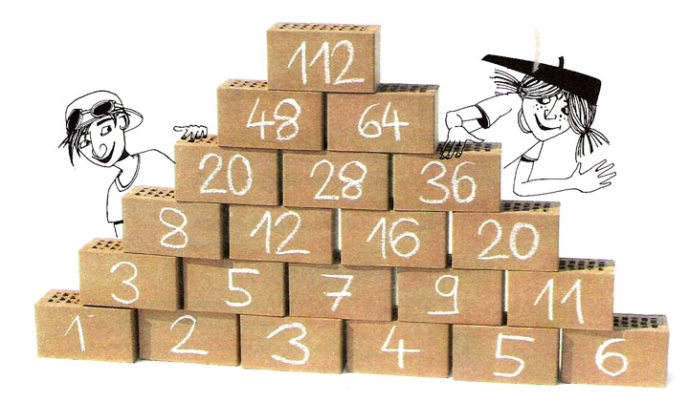

**2.** Schreibe deine Überlegungen auf. Lass deine Versuche stehen!

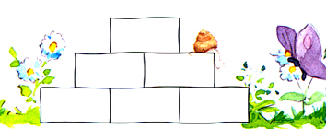

**3.** Wie bist du vorgegangen? Was hast du dir überlegt?

|  |  |  |  |  |  |  |  |  |  |  |  |  |  |  |  |  |  |  |  |  |  |  |  |  |  |  |  |  |  |  |  |  |  |  |  |
| --- | --- | --- | --- | --- | --- | --- | --- | --- | --- | --- | --- | --- | --- | --- | --- | --- | --- | --- | --- | --- | --- | --- | --- | --- | --- | --- | --- | --- | --- | --- | --- | --- | --- | --- | --- |
|  |  |  |  |  |  |  |  |  |  |  |  |  |  |  |  |  |  |  |  |  |  |  |  |  |  |  |  |  |  |  |  |  |  |  |  |
|  |  |  |  |  |  |  |  |  |  |  |  |  |  |  |  |  |  |  |  |  |  |  |  |  |  |  |  |  |  |  |  |  |  |  |  |
|  |  |  |  |  |  |  |  |  |  |  |  |  |  |  |  |  |  |  |  |  |  |  |  |  |  |  |  |  |  |  |  |  |  |  |  |
|  |  |  |  |  |  |  |  |  |  |  |  |  |  |  |  |  |  |  |  |  |  |  |  |  |  |  |  |  |  |  |  |  |  |  |  |
|  |  |  |  |  |  |  |  |  |  |  |  |  |  |  |  |  |  |  |  |  |  |  |  |  |  |  |  |  |  |  |  |  |  |  |  |
|  |  |  |  |  |  |  |  |  |  |  |  |  |  |  |  |  |  |  |  |  |  |  |  |  |  |  |  |  |  |  |  |  |  |  |  |
|  |  |  |  |  |  |  |  |  |  |  |  |  |  |  |  |  |  |  |  |  |  |  |  |  |  |  |  |  |  |  |  |  |  |  |  |
|  |  |  |  |  |  |  |  |  |  |  |  |  |  |  |  |  |  |  |  |  |  |  |  |  |  |  |  |  |  |  |  |  |  |  |  |
|  |  |  |  |  |  |  |  |  |  |  |  |  |  |  |  |  |  |  |  |  |  |  |  |  |  |  |  |  |  |  |  |  |  |  |  |
|  |  |  |  |  |  |  |  |  |  |  |  |  |  |  |  |  |  |  |  |  |  |  |  |  |  |  |  |  |  |  |  |  |  |  |  |
|  |  |  |  |  |  |  |  |  |  |  |  |  |  |  |  |  |  |  |  |  |  |  |  |  |  |  |  |  |  |  |  |  |  |  |  |
|  |  |  |  |  |  |  |  |  |  |  |  |  |  |  |  |  |  |  |  |  |  |  |  |  |  |  |  |  |  |  |  |  |  |  |  |

**4.** Beschreibe die Zahlenmauer.



|  |  |  |  |  |  |  |  |  |  |  |  |  |  |  |  |  |  |  |  |  |  |  |  |  |  |  |  |  |  |  |  |  |  |  |  |
| --- | --- | --- | --- | --- | --- | --- | --- | --- | --- | --- | --- | --- | --- | --- | --- | --- | --- | --- | --- | --- | --- | --- | --- | --- | --- | --- | --- | --- | --- | --- | --- | --- | --- | --- | --- |
|  |  |  |  |  |  |  |  |  |  |  |  |  |  |  |  |  |  |  |  |  |  |  |  |  |  |  |  |  |  |  |  |  |  |  |  |
|  |  |  |  |  |  |  |  |  |  |  |  |  |  |  |  |  |  |  |  |  |  |  |  |  |  |  |  |  |  |  |  |  |  |  |  |
|  |  |  |  |  |  |  |  |  |  |  |  |  |  |  |  |  |  |  |  |  |  |  |  |  |  |  |  |  |  |  |  |  |  |  |  |
|  |  |  |  |  |  |  |  |  |  |  |  |  |  |  |  |  |  |  |  |  |  |  |  |  |  |  |  |  |  |  |  |  |  |  |  |
|  |  |  |  |  |  |  |  |  |  |  |  |  |  |  |  |  |  |  |  |  |  |  |  |  |  |  |  |  |  |  |  |  |  |  |  |
|  |  |  |  |  |  |  |  |  |  |  |  |  |  |  |  |  |  |  |  |  |  |  |  |  |  |  |  |  |  |  |  |  |  |  |  |
|  |  |  |  |  |  |  |  |  |  |  |  |  |  |  |  |  |  |  |  |  |  |  |  |  |  |  |  |  |  |  |  |  |  |  |  |
|  |  |  |  |  |  |  |  |  |  |  |  |  |  |  |  |  |  |  |  |  |  |  |  |  |  |  |  |  |  |  |  |  |  |  |  |
|  |  |  |  |  |  |  |  |  |  |  |  |  |  |  |  |  |  |  |  |  |  |  |  |  |  |  |  |  |  |  |  |  |  |  |  |
|  |  |  |  |  |  |  |  |  |  |  |  |  |  |  |  |  |  |  |  |  |  |  |  |  |  |  |  |  |  |  |  |  |  |  |  |
|  |  |  |  |  |  |  |  |  |  |  |  |  |  |  |  |  |  |  |  |  |  |  |  |  |  |  |  |  |  |  |  |  |  |  |  |
|  |  |  |  |  |  |  |  |  |  |  |  |  |  |  |  |  |  |  |  |  |  |  |  |  |  |  |  |  |  |  |  |  |  |  |  |
|  |  |  |  |  |  |  |  |  |  |  |  |  |  |  |  |  |  |  |  |  |  |  |  |  |  |  |  |  |  |  |  |  |  |  |  |
|  |  |  |  |  |  |  |  |  |  |  |  |  |  |  |  |  |  |  |  |  |  |  |  |  |  |  |  |  |  |  |  |  |  |  |  |
|  |  |  |  |  |  |  |  |  |  |  |  |  |  |  |  |  |  |  |  |  |  |  |  |  |  |  |  |  |  |  |  |  |  |  |  |
|  |  |  |  |  |  |  |  |  |  |  |  |  |  |  |  |  |  |  |  |  |  |  |  |  |  |  |  |  |  |  |  |  |  |  |  |
|  |  |  |  |  |  |  |  |  |  |  |  |  |  |  |  |  |  |  |  |  |  |  |  |  |  |  |  |  |  |  |  |  |  |  |  |
|  |  |  |  |  |  |  |  |  |  |  |  |  |  |  |  |  |  |  |  |  |  |  |  |  |  |  |  |  |  |  |  |  |  |  |  |
|  |  |  |  |  |  |  |  |  |  |  |  |  |  |  |  |  |  |  |  |  |  |  |  |  |  |  |  |  |  |  |  |  |  |  |  |
|  |  |  |  |  |  |  |  |  |  |  |  |  |  |  |  |  |  |  |  |  |  |  |  |  |  |  |  |  |  |  |  |  |  |  |  |
|  |  |  |  |  |  |  |  |  |  |  |  |  |  |  |  |  |  |  |  |  |  |  |  |  |  |  |  |  |  |  |  |  |  |  |  |
|  |  |  |  |  |  |  |  |  |  |  |  |  |  |  |  |  |  |  |  |  |  |  |  |  |  |  |  |  |  |  |  |  |  |  |  |
|  |  |  |  |  |  |  |  |  |  |  |  |  |  |  |  |  |  |  |  |  |  |  |  |  |  |  |  |  |  |  |  |  |  |  |  |
|  |  |  |  |  |  |  |  |  |  |  |  |  |  |  |  |  |  |  |  |  |  |  |  |  |  |  |  |  |  |  |  |  |  |  |  |
|  |  |  |  |  |  |  |  |  |  |  |  |  |  |  |  |  |  |  |  |  |  |  |  |  |  |  |  |  |  |  |  |  |  |  |  |
|  |  |  |  |  |  |  |  |  |  |  |  |  |  |  |  |  |  |  |  |  |  |  |  |  |  |  |  |  |  |  |  |  |  |  |  |
|  |  |  |  |  |  |  |  |  |  |  |  |  |  |  |  |  |  |  |  |  |  |  |  |  |  |  |  |  |  |  |  |  |  |  |  |
|  |  |  |  |  |  |  |  |  |  |  |  |  |  |  |  |  |  |  |  |  |  |  |  |  |  |  |  |  |  |  |  |  |  |  |  |
|  |  |  |  |  |  |  |  |  |  |  |  |  |  |  |  |  |  |  |  |  |  |  |  |  |  |  |  |  |  |  |  |  |  |  |  |
|  |  |  |  |  |  |  |  |  |  |  |  |  |  |  |  |  |  |  |  |  |  |  |  |  |  |  |  |  |  |  |  |  |  |  |  |
|  |  |  |  |  |  |  |  |  |  |  |  |  |  |  |  |  |  |  |  |  |  |  |  |  |  |  |  |  |  |  |  |  |  |  |  |
|  |  |  |  |  |  |  |  |  |  |  |  |  |  |  |  |  |  |  |  |  |  |  |  |  |  |  |  |  |  |  |  |  |  |  |  |