

|  |  |
| --- | --- |
| Forscherauftrag: **Körper** | Name: ………………… |

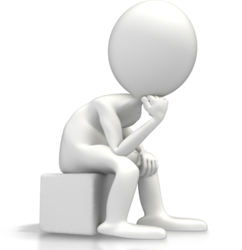

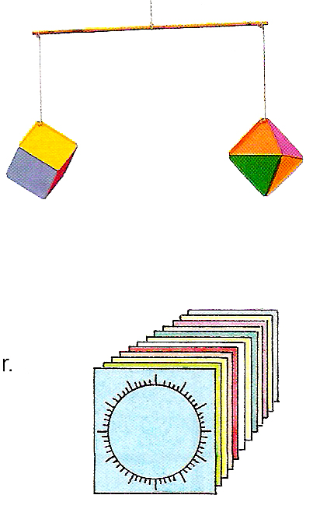**1.** Ein Hexaeder (Würfel) hat 6 Flächen. Jede Fläche besteht aus einem Quadrat. Ein Oktaeder hat 8 Flächen.  
Jede Fläche besteht aus einem Dreieck.

Hexaeder (Würfel) Oktaeder

Stelle mit Hilfe der Zeichenuhr (Kopiervorlage) einen Hexaeder und einen Oktaeder her.

Hexaeder: 6 Quadrate

Oktaeder: 8 Dreiecke



**2.** Hexaeder: Zeichne 6-mal ein Quadrat und schneide jeweils den Kreis aus.

**3.** Knicke die Quadrate und lass die überstehenden Flächen als Klebelaschen

stehen.

**4.** Setze die sechs Quadrate zu einem Würfel zusammen.

**5.** Überlege, wie du beim Erstellen eines Oktaeders vorgehen willst.

Schreibe eine Anleitung

|  |  |  |  |  |  |  |  |  |  |  |  |  |  |  |  |  |  |  |  |  |  |  |  |  |  |  |  |  |  |  |  |  |  |  |  |
| --- | --- | --- | --- | --- | --- | --- | --- | --- | --- | --- | --- | --- | --- | --- | --- | --- | --- | --- | --- | --- | --- | --- | --- | --- | --- | --- | --- | --- | --- | --- | --- | --- | --- | --- | --- |
|  |  |  |  |  |  |  |  |  |  |  |  |  |  |  |  |  |  |  |  |  |  |  |  |  |  |  |  |  |  |  |  |  |  |  |  |
|  |  |  |  |  |  |  |  |  |  |  |  |  |  |  |  |  |  |  |  |  |  |  |  |  |  |  |  |  |  |  |  |  |  |  |  |
|  |  |  |  |  |  |  |  |  |  |  |  |  |  |  |  |  |  |  |  |  |  |  |  |  |  |  |  |  |  |  |  |  |  |  |  |
|  |  |  |  |  |  |  |  |  |  |  |  |  |  |  |  |  |  |  |  |  |  |  |  |  |  |  |  |  |  |  |  |  |  |  |  |
|  |  |  |  |  |  |  |  |  |  |  |  |  |  |  |  |  |  |  |  |  |  |  |  |  |  |  |  |  |  |  |  |  |  |  |  |
|  |  |  |  |  |  |  |  |  |  |  |  |  |  |  |  |  |  |  |  |  |  |  |  |  |  |  |  |  |  |  |  |  |  |  |  |
|  |  |  |  |  |  |  |  |  |  |  |  |  |  |  |  |  |  |  |  |  |  |  |  |  |  |  |  |  |  |  |  |  |  |  |  |
|  |  |  |  |  |  |  |  |  |  |  |  |  |  |  |  |  |  |  |  |  |  |  |  |  |  |  |  |  |  |  |  |  |  |  |  |
|  |  |  |  |  |  |  |  |  |  |  |  |  |  |  |  |  |  |  |  |  |  |  |  |  |  |  |  |  |  |  |  |  |  |  |  |
|  |  |  |  |  |  |  |  |  |  |  |  |  |  |  |  |  |  |  |  |  |  |  |  |  |  |  |  |  |  |  |  |  |  |  |  |
|  |  |  |  |  |  |  |  |  |  |  |  |  |  |  |  |  |  |  |  |  |  |  |  |  |  |  |  |  |  |  |  |  |  |  |  |
|  |  |  |  |  |  |  |  |  |  |  |  |  |  |  |  |  |  |  |  |  |  |  |  |  |  |  |  |  |  |  |  |  |  |  |  |
|  |  |  |  |  |  |  |  |  |  |  |  |  |  |  |  |  |  |  |  |  |  |  |  |  |  |  |  |  |  |  |  |  |  |  |  |
|  |  |  |  |  |  |  |  |  |  |  |  |  |  |  |  |  |  |  |  |  |  |  |  |  |  |  |  |  |  |  |  |  |  |  |  |
|  |  |  |  |  |  |  |  |  |  |  |  |  |  |  |  |  |  |  |  |  |  |  |  |  |  |  |  |  |  |  |  |  |  |  |  |
|  |  |  |  |  |  |  |  |  |  |  |  |  |  |  |  |  |  |  |  |  |  |  |  |  |  |  |  |  |  |  |  |  |  |  |  |
|  |  |  |  |  |  |  |  |  |  |  |  |  |  |  |  |  |  |  |  |  |  |  |  |  |  |  |  |  |  |  |  |  |  |  |  |
|  |  |  |  |  |  |  |  |  |  |  |  |  |  |  |  |  |  |  |  |  |  |  |  |  |  |  |  |  |  |  |  |  |  |  |  |
|  |  |  |  |  |  |  |  |  |  |  |  |  |  |  |  |  |  |  |  |  |  |  |  |  |  |  |  |  |  |  |  |  |  |  |  |
|  |  |  |  |  |  |  |  |  |  |  |  |  |  |  |  |  |  |  |  |  |  |  |  |  |  |  |  |  |  |  |  |  |  |  |  |
|  |  |  |  |  |  |  |  |  |  |  |  |  |  |  |  |  |  |  |  |  |  |  |  |  |  |  |  |  |  |  |  |  |  |  |  |
|  |  |  |  |  |  |  |  |  |  |  |  |  |  |  |  |  |  |  |  |  |  |  |  |  |  |  |  |  |  |  |  |  |  |  |  |
|  |  |  |  |  |  |  |  |  |  |  |  |  |  |  |  |  |  |  |  |  |  |  |  |  |  |  |  |  |  |  |  |  |  |  |  |
|  |  |  |  |  |  |  |  |  |  |  |  |  |  |  |  |  |  |  |  |  |  |  |  |  |  |  |  |  |  |  |  |  |  |  |  |
|  |  |  |  |  |  |  |  |  |  |  |  |  |  |  |  |  |  |  |  |  |  |  |  |  |  |  |  |  |  |  |  |  |  |  |  |
|  |  |  |  |  |  |  |  |  |  |  |  |  |  |  |  |  |  |  |  |  |  |  |  |  |  |  |  |  |  |  |  |  |  |  |  |
|  |  |  |  |  |  |  |  |  |  |  |  |  |  |  |  |  |  |  |  |  |  |  |  |  |  |  |  |  |  |  |  |  |  |  |  |
|  |  |  |  |  |  |  |  |  |  |  |  |  |  |  |  |  |  |  |  |  |  |  |  |  |  |  |  |  |  |  |  |  |  |  |  |
|  |  |  |  |  |  |  |  |  |  |  |  |  |  |  |  |  |  |  |  |  |  |  |  |  |  |  |  |  |  |  |  |  |  |  |  |
|  |  |  |  |  |  |  |  |  |  |  |  |  |  |  |  |  |  |  |  |  |  |  |  |  |  |  |  |  |  |  |  |  |  |  |  |
|  |  |  |  |  |  |  |  |  |  |  |  |  |  |  |  |  |  |  |  |  |  |  |  |  |  |  |  |  |  |  |  |  |  |  |  |
|  |  |  |  |  |  |  |  |  |  |  |  |  |  |  |  |  |  |  |  |  |  |  |  |  |  |  |  |  |  |  |  |  |  |  |  |
|  |  |  |  |  |  |  |  |  |  |  |  |  |  |  |  |  |  |  |  |  |  |  |  |  |  |  |  |  |  |  |  |  |  |  |  |
|  |  |  |  |  |  |  |  |  |  |  |  |  |  |  |  |  |  |  |  |  |  |  |  |  |  |  |  |  |  |  |  |  |  |  |  |
|  |  |  |  |  |  |  |  |  |  |  |  |  |  |  |  |  |  |  |  |  |  |  |  |  |  |  |  |  |  |  |  |  |  |  |  |
|  |  |  |  |  |  |  |  |  |  |  |  |  |  |  |  |  |  |  |  |  |  |  |  |  |  |  |  |  |  |  |  |  |  |  |  |
|  |  |  |  |  |  |  |  |  |  |  |  |  |  |  |  |  |  |  |  |  |  |  |  |  |  |  |  |  |  |  |  |  |  |  |  |
|  |  |  |  |  |  |  |  |  |  |  |  |  |  |  |  |  |  |  |  |  |  |  |  |  |  |  |  |  |  |  |  |  |  |  |  |
|  |  |  |  |  |  |  |  |  |  |  |  |  |  |  |  |  |  |  |  |  |  |  |  |  |  |  |  |  |  |  |  |  |  |  |  |
|  |  |  |  |  |  |  |  |  |  |  |  |  |  |  |  |  |  |  |  |  |  |  |  |  |  |  |  |  |  |  |  |  |  |  |  |
|  |  |  |  |  |  |  |  |  |  |  |  |  |  |  |  |  |  |  |  |  |  |  |  |  |  |  |  |  |  |  |  |  |  |  |  |
|  |  |  |  |  |  |  |  |  |  |  |  |  |  |  |  |  |  |  |  |  |  |  |  |  |  |  |  |  |  |  |  |  |  |  |  |
|  |  |  |  |  |  |  |  |  |  |  |  |  |  |  |  |  |  |  |  |  |  |  |  |  |  |  |  |  |  |  |  |  |  |  |  |
|  |  |  |  |  |  |  |  |  |  |  |  |  |  |  |  |  |  |  |  |  |  |  |  |  |  |  |  |  |  |  |  |  |  |  |  |
|  |  |  |  |  |  |  |  |  |  |  |  |  |  |  |  |  |  |  |  |  |  |  |  |  |  |  |  |  |  |  |  |  |  |  |  |
|  |  |  |  |  |  |  |  |  |  |  |  |  |  |  |  |  |  |  |  |  |  |  |  |  |  |  |  |  |  |  |  |  |  |  |  |
|  |  |  |  |  |  |  |  |  |  |  |  |  |  |  |  |  |  |  |  |  |  |  |  |  |  |  |  |  |  |  |  |  |  |  |  |